Project Report

|  |  |
| --- | --- |
| Product Name | Advanced Certificate in Web Development |
| Qualification Name (ITSF) | NICF-Advanced Certificate in Infocomm Technology (Software & Applications) |
| Product Name | Web Development Foundations |
| Module Name (ITSF) | NICF -Web Development Foundations |

|  |  |  |  |
| --- | --- | --- | --- |
| Student name | | Assessor name | |
| WeeChong, Teo | |  | |
| Date issued | Completion date | | Submitted on |
| 18 May 2022 | 14 June 2022 | | 14 June 2022 |
|  | |  | |
| Project title | Design, Develop, Implement & Document Community Portal Website | | |

|  |
| --- |
| Learner declaration |
| I certify that the work submitted for this assignment is my own and research sources are fully acknowledged.  Student signature: Date: |

Content

1. Project background
2. Project Objectives
3. System Requirement Specifications
4. Task 1
5. Task 2
6. Task 3
7. Task 4
8. Task 5
9. Task 6
10. Task 7
11. Task 8
12. Task 9
13. Task 10
14. Task 11

# Project Background

Over the years, ABC Job Center has helped millions of people find jobs and has equipped hundreds of thousands of employers with the talent they need.

As an industry leader, ABC Job Center works with companies big and small, providing cutting-edge solutions for everything from recruiting to employment screening and human capital management.

# Project Objectives

ABC Jobs Pte Ltd wants to develop a community portal for Software Developers, similar to Linkedln.com.

## Project Scope

The scope of the project is to design a Community Portal Similar to Linkedin.com. Users will be able to register in the portal using the Registration Page. Users of the portal can search for other users using various parameters such as First Name, Last Name, Company Name, City & Country. Users will be able to view the Public Profile of users after searching them. The portal allows users to login, request for forgotten password and update their profile information

The overview of the project is as below.

There are 2 types of users in this Community portal. They are

1. Software Programmer
2. Administrator

Software Programmer should be able to perform following functions in the portal

1. Allow the programmers to register in the portal, show a thank you page & send a registration confirmation email.
2. Search & Find Other Programmers after login and view their profile.
3. Provide Login Page
4. Provide password retrieval functionality.
5. Update their Profile after logging in.

Administrator should be able to perform following functions in the portal

1. Administer user data.
2. Send bulk email inviting programmers to register on the community portal

The following is out of scope

1. Database replication

## Tools and Platforms

|  |  |
| --- | --- |
| MySQL Server | MySQL is an open-source relational database management system (RDBMS) with a client-server model. RDBMS is a software or service used to create and manage databases based on a relational model. |
| MySQL Workbench | MySQL Workbench is a unified visual tool for database architects, developers, and DBAs. MySQL Workbench provides data modelling, SQL development, and comprehensive administration tools for server configuration, user administration, backup, and much more. |
| phpMyAdmin | phpMyAdmin is a free software tool written in PHP, intended to handle the administration of MySQL over the Web. |
| JDK 1.8 | Java Development Kit 1.8 |
| Apache Tomcat Server | Apache Tomcat is a free and open-source implementation of the Jakarta Servlet, Jakarta Expression Language, and WebSocket technologies. Tomcat provides a "pure Java" HTTP web server environment in which Java code can run. |
| Spring Framework | The Spring Framework is an application framework and inversion of control container for the Java platform. |
| diagrams.net/draw.io | diagrams.net/draw.io is an open source technology stack for building diagramming applications |
| Visual Studio Code | IDE for developing the HTML, CSS, JavaScript. |
| Eclipse IDE | IDE for Java, JSP development |
| Microsoft Word | Word processing application for creating this report. |
| Microsoft PowerPoint | Application for creating presentation slides. |
| Windows 10 Operating System | All the above-mentioned tools are executed within the Windows 10 operating system. |

# System Requirement Specification

## Functional Requirement

Functionalities of the community portal

|  |  |  |
| --- | --- | --- |
| S/N | Page | Description |
| 1 | Community Portal Home Page | This is the landing page |
| 2 | Registration Page | New user register through this page |
| 3 | Registration Confirmation Page | A confirmation page for successful registration |
| 4 | Login Page | This page allows registered user to login |
| 5 | Forget Password Page | This page allows user to request to reset his/her password |
| 6 | Forget Password Change Password Page | This page shows a message to inform that a reset link has been sent |
| 7 | Forget Password Change Password Page | This page allows user to change password from the reset link email |
| 8 | Update Profile Page | This page allows user to update his/her profile information |
| 9 | Search Users Page | A function to allow login user to search for other registered members |
| 10 | List Search Results | The result for the search for registered members |
| 11 | Public Profile Page | This page shows the public profile information of a selected registered member |
| 12 | Send Message | Send a message to another member |
| 13 | Read Message | Read a message from a member |
| 14 | List Message Board (Thread) | List the thread discussions |
| 15 | Post A Thread | Post a thread discussion topic |
| 16 | Read A Thread | Read a thread discussion topic |
| 17 | Post A Job | Post a new job posting |
| 18 | Apply A Job | Apply a job from the list of job postings |
| 19 | List Job Opportunities and Responses | Display the list of job postings and the number of applicants |

Administrative functionalities of the community portal

|  |  |  |
| --- | --- | --- |
| S/N | Page | Description |
| 1 | Administer User Data | Administrative function to list user account information and to request to reset user account password. |
| 2 | Send Bulk Email | Import a list of emails and use them to send invitations |

## Non-Functional Requirement

1. System must be able to scale when traffic volume increase.
2. System must be available 24/7 with at least 99.9% uptime.
3. Each page must load within 3 seconds.
4. All data store must be secured.
5. Each page must load within 2 seconds.
6. Daily system maintenance must finish within 3 hours so data is available by 8 a.m. local time after an overnight update.

## Technical Requirement

1. Software
   1. MySQL Relational Database System
   2. MySQL Server
   3. MySQL Workbench
   4. phpMyAdmin
   5. JDK 1.8
   6. Apache Tomcat Server
   7. Spring Framework
   8. Microsoft Word
   9. Microsoft PowerPoint
   10. Programming Languages: HTML, CSS, JavaScript, jQuery, Structured Query Language
2. Hardware
   1. Client (User) – Windows 10 and above. Mac 10.11 and above
   2. Server – Windows Server, MySQL Server

# Task 1

**Task Statement:**

Create the following items in “Technical Design” Section in Project Report

1. Architecture of the System
2. Draw the Block diagram of the system
3. Explain the Architecture of the application
4. System
5. List down all the Modules to be developed
6. List down all the pages in each of the module and briefly describe the purpose
7. Note down which are Create, Edit & View Pages
8. Create the Sitemap of Public & Private Site
9. Technical Environment Requirements
10. System Integration Requirements
11. Portability Requirements
12. Maintainability Requirements
13. Performance Requirements
14. Security Requirements
15. List down the Security Access for different kind of users
16. Briefly explain Login & Logout mechanism

**Solution:**

## Architecture of the System

### System Architecture

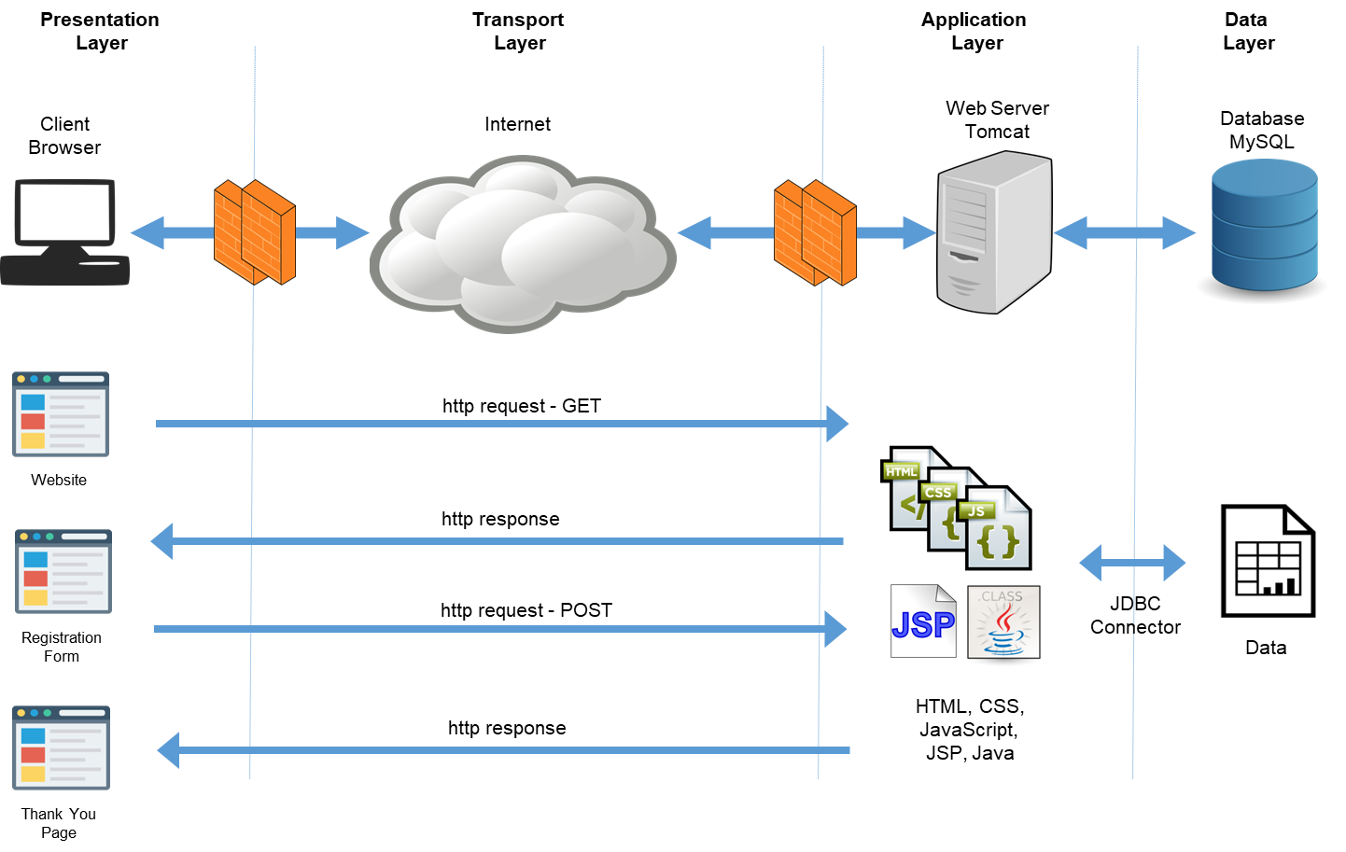

### Application Architecture

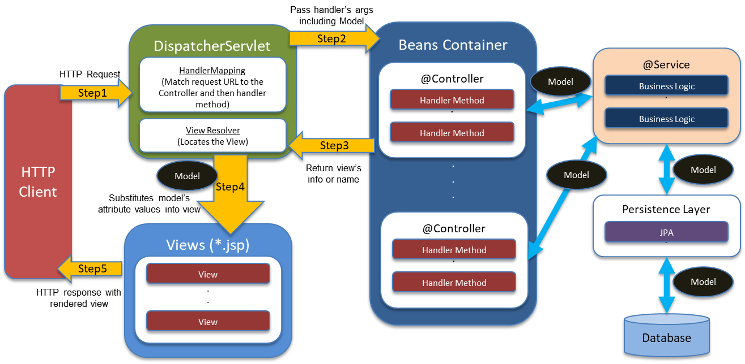

The application architecture is based on the concept of the Front Controller as in the typical Spring Model View Controller architecture. The DispatcherServlet plays the role of the Front Controller in the architecture.

The request comes in from the HTTP client. The DispatcherServlet will pass the request to the appropriate handler method according to the request mapping. The controller uses the service controllers to perform business logics which interact with the database via the JPA persistence layer. The controller will return the view name to the DispatcherServlet who will return the rendered view via the View Resolver.

## System

Two modules are to be developed in this project. The two modules are

1. Community Portal Module – This is a public module whereby the general public can access.
2. Administrative Module – This is a restricted module whereby only the administrator can access to perform administrative functions.

### Community Portal Module

The table shows the pages in the community portal module where the software developers can access.

|  |  |  |  |
| --- | --- | --- | --- |
| S/N | Page | Description | Page Type |
| 1 | Community Portal Home Page | This is the landing page |  |
| 2 | Registration Page | New user register through this page | Create |
| 3 | Registration Confirmation Page | A confirmation page for successful registration | View |
| 4 | Login Page | This page allows registered user to login | View |
| 5 | Forget Password Page | This page allows user to request to reset his/her password | Edit |
| 6 | Forget Password Change Password Page | This page shows a message to inform that a reset link has been sent | View |
| 7 | Forget Password Change Password Page | This page allows user to change password from the reset link email | Edit |
| 8 | Update Profile Page | This page allows user to update his/her profile information | Create for new profile  Edit for update profile |
| 9 | Search Users Page | A function to allow login user to search for other registered members | View |
| 10 | List Search Results | The result for the search for registered members | View |
| 11 | Public Profile Page | This page shows the public profile information of a selected registered member | View |
| 12 | Send Message | Send a message to another member | Create |
| 13 | Read Message | Read a message from a member | View |
| 14 | List Message Board (Thread) | List the thread discussions | View |
| 15 | Post A Thread | Post a thread discussion topic | Create |
| 16 | Read A Thread | Read a thread discussion topic | View |
| 17 | Post A Job | Post a new job posting | Create |
| 18 | Apply A Job | Apply a job from the list of job postings | Create |
| 19 | List Job Opportunities and Responses | Display the list of job postings and the number of applicants | View |

### Administrative Module

The table shows the pages in the administrative module where the administrator is given access.

|  |  |  |  |
| --- | --- | --- | --- |
| S/N | Page | Description | Page Type |
| 1 | Administer User Data | Administrative function to list user account information and to request to reset user account password. | View, Create |
| 2 | Send Bulk Email | Import a list of emails and use them to send invitations | Create, View |

### Sitemap

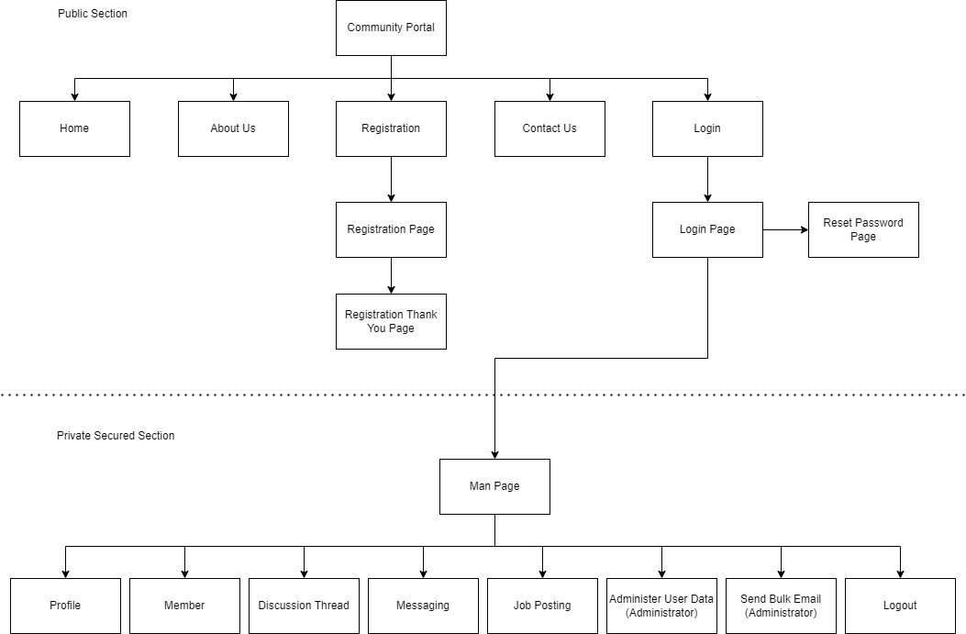

## Technical Environment Requirements

1. Software
   1. MySQL Relational Database System
   2. MySQL Server 8.0.29
   3. MySQL Workbench 8.0.29
   4. phpMyAdmin
   5. JDK 1.8
   6. Apache Tomcat Server 9.0.59
   7. Spring Framework 5.x
   8. Microsoft Word
   9. Microsoft PowerPoint
   10. Programming Languages: HTML, CSS, JavaScript, jQuery, Structured Query Language
2. Hardware
   1. Client (User) – Windows 10 and above. Mac 10.11 and above
   2. Server – Windows Server, MySQL Server
   3. Firewall with port numbers 8080, 3306 accessible

## System Integration Requirements

### Database

JDBC Connector 8.0.29 - Connection to MySQL database using JDBC connections.

### Mail Server

Javax Mail API - Sending of registration confirmation email, reset password link email and buik invitation emails require a mail server.

## Portability Requirements

### Server

The backend server code is written in Java hosted in Tomcat on Windows platform. The code can be ported to Linux platform that provide the same stack of server software.

### Client

The front end runs on browser. Therefore, it must be compatible with different browser applications not limited to Chrome, Safari, Edge and Firefox browsers. All devices – Desktop, Tablets or Mobile that can run the browser application will be able to access the system.

## Maintainability Requirements

### Database

Backup script to back up the database every 6 hours. Restore script to restore the database in event of failure.

Database maintenance must finish within 3 hours so data is available by 8 a.m. local time after an overnight update.

### Application

Application update must finish within 3 hours so system is available by 8 a.m. local time after an overnight update.

## Performance Requirements

System must be able to scale when traffic volume increase with up to 1000 concurrent users. System must be available 24/7 with at least 99.9% uptime.

Each page must load within 3 seconds.

## Security Requirements

### Client-Server Communication

For secured communication between the client and server, we will use HTTPS over SSL/TLS.

### Spring Security

Spring Security is a framework that focuses on providing both authentication and authorization to Java applications.

In order to access the system, login is required. Spring Security will provide the authentication feature.

The permission to access the application function is restricted by roles – Member or Administrator. This will be handled by Spring authorization feature.

### Password

Passwords should not be stored in the clear in the database. Passwords are stored with irreversible cryptographic functions.

Request to reset password are to be time constraint. Reset request that has expired should not proceed with the password change.

#### List down the Security Access for different kind of users

|  |  |  |  |  |
| --- | --- | --- | --- | --- |
| S/N | Page | Visitor | Registered Member | Administrator |
| 1 | Community Portal Home Page | 🗸 | 🗸 | 🗸 |
| 2 | Registration Page | 🗸 | 🗸 | 🗸 |
| 3 | Registration Confirmation Page | 🗸 | 🗸 | 🗸 |
| 4 | Login Page | 🗸 | 🗸 | 🗸 |
| 5 | Forget Password Page | 🗸 | 🗸 | 🗸 |
| 6 | Forget Password Change Password Page | 🗸 | 🗸 | 🗸 |
| 7 | Update Profile Page |  | 🗸 |  |
| 8 | Search Users Page |  | 🗸 |  |
| 9 | List Search Results |  | 🗸 |  |
| 10 | Public Profile Page |  | 🗸 |  |
| 11 | Send Message |  | 🗸 |  |
| 12 | Read Message |  | 🗸 |  |
| 13 | List Message Board (Thread) |  | 🗸 |  |
| 14 | Post A Thread |  | 🗸 |  |
| 15 | Read A Thread |  | 🗸 |  |
| 16 | Post A Job |  | 🗸 |  |
| 17 | Apply A Job |  | 🗸 |  |
| 18 | List Job Opportunities and Responses |  | 🗸 |  |
| 19 | Administer User Data |  |  | 🗸 |
| 20 | Send Bulk Email |  |  | 🗸 |

#### Briefly explain Login & Logout mechanism

**Login**

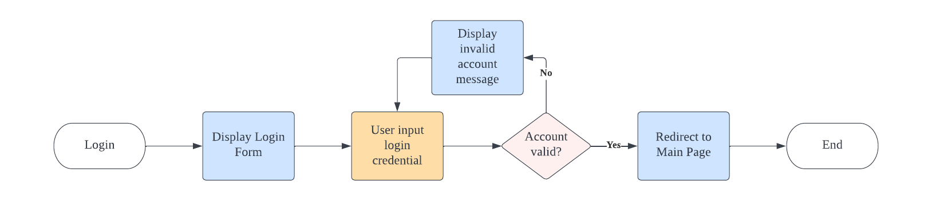

**Logout**

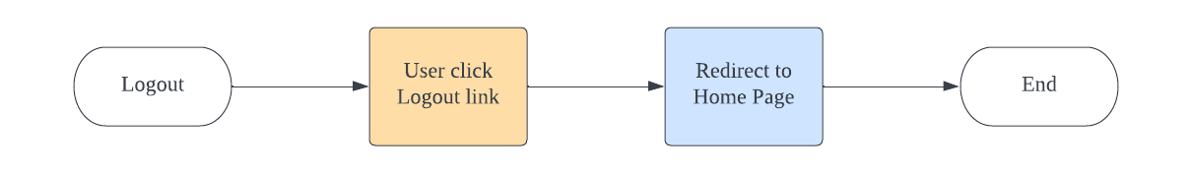

When a user login to the system, a session is created between the client and server. Only after this can multiple requests be sent to the server. Once a user logout, the session will be invalidated to prevent any further client request to the server.

# Task 2

**Task Statement:**

1. Install Eclipse in your laptop
2. Provide screen capture of eclipse IDE
3. Include it as part of Project Presentation

**Solution:**

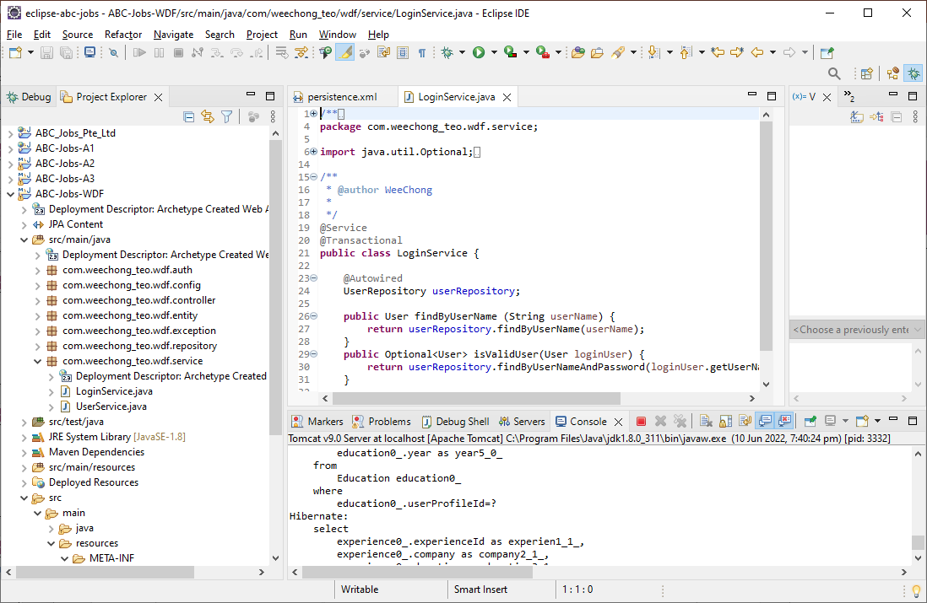

# Task 3

**Task Statement:**

1. Provide description of 3 features in IDE along with the screen capture of their use.
2. Include it as part of Project Presentation

**Solution:**

## Java Perspective

The java perspective offers developer to view the code organized in java packages.

The Package Explorer view allows you to browse the structure of your projects and to open files in an editor via a double-click on the file.

The Outline view shows the structure of the currently selected java source file.

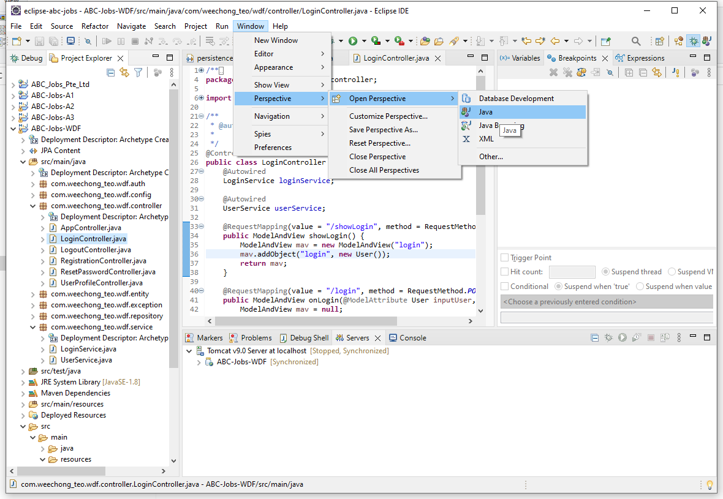

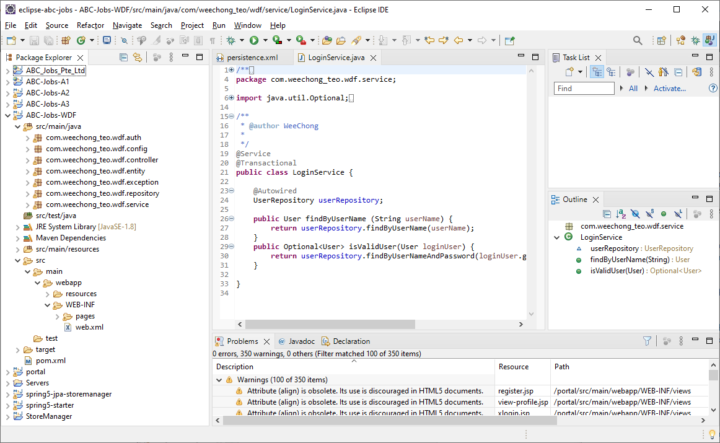

## Debugger

Eclipse allows you to start a Java program in Debug mode.

Eclipse provides a Debug perspective which gives you a pre-configured set of views. Eclipse allows you to control the execution flow via debug commands.

The debugger allows you to control and trace through the execution flow with breakpoints. The Variables view displays fields and local variables from the current executing stack.

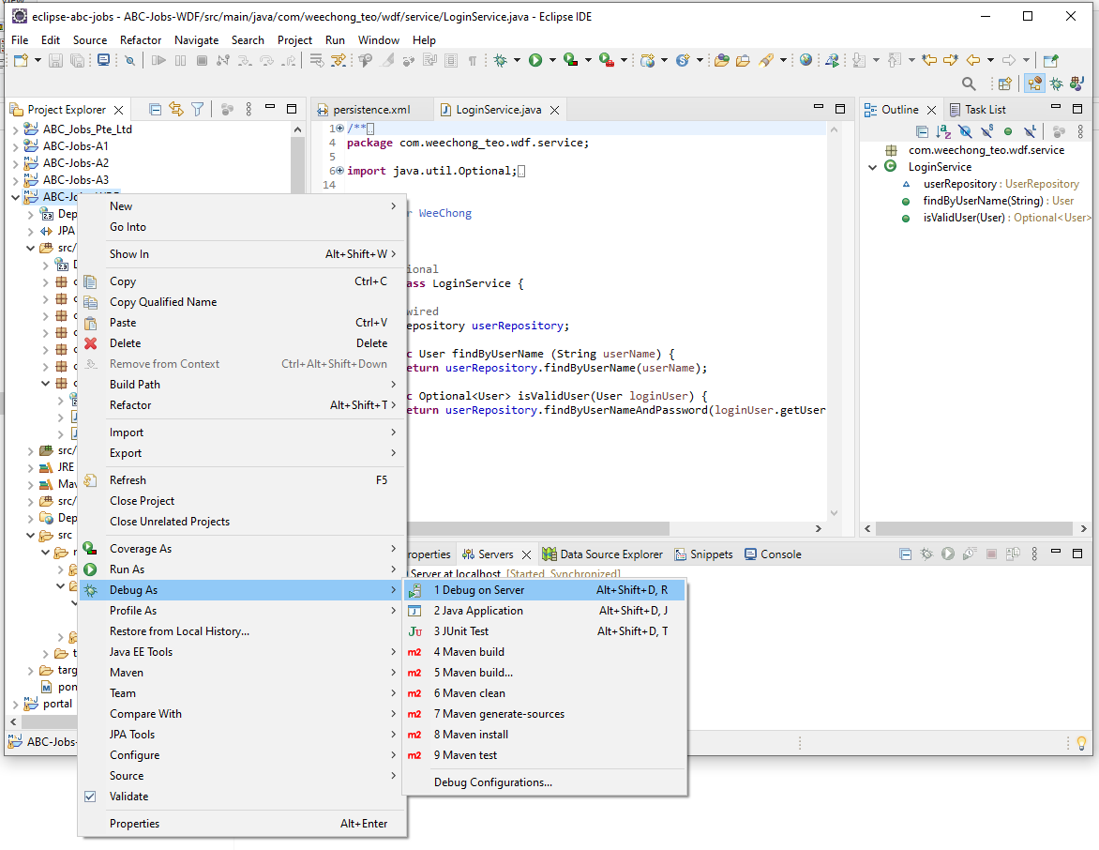

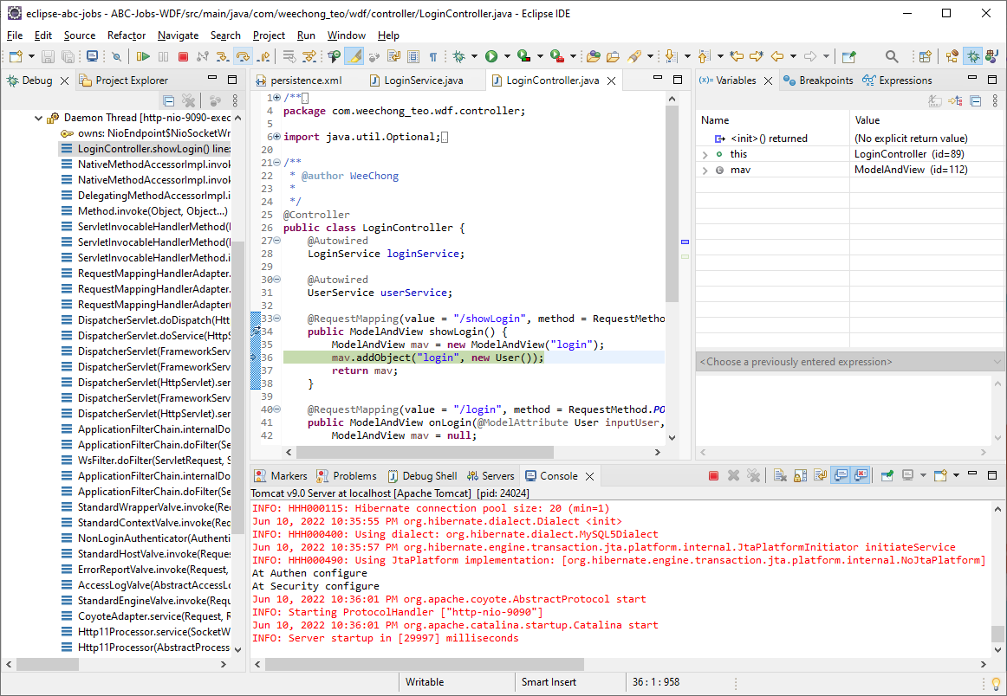

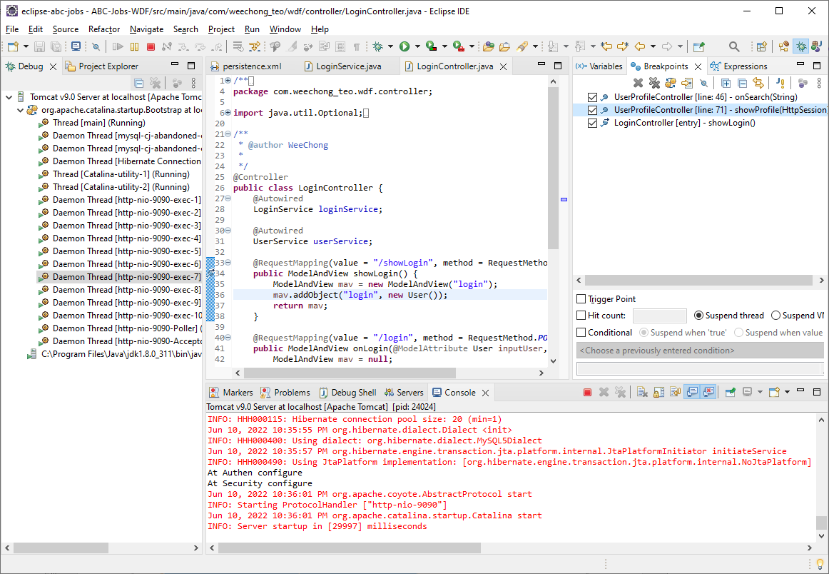

## Refactoring

Eclipse supports several refactoring activities, for example, renaming or moving.

For example, to use the Rename refactoring, you can right-click on your class (in the editor or Package Explorer) and select Refactor -> Rename to rename your class. Eclipse will make sure that all calls in your Workspace to your class or method are renamed.

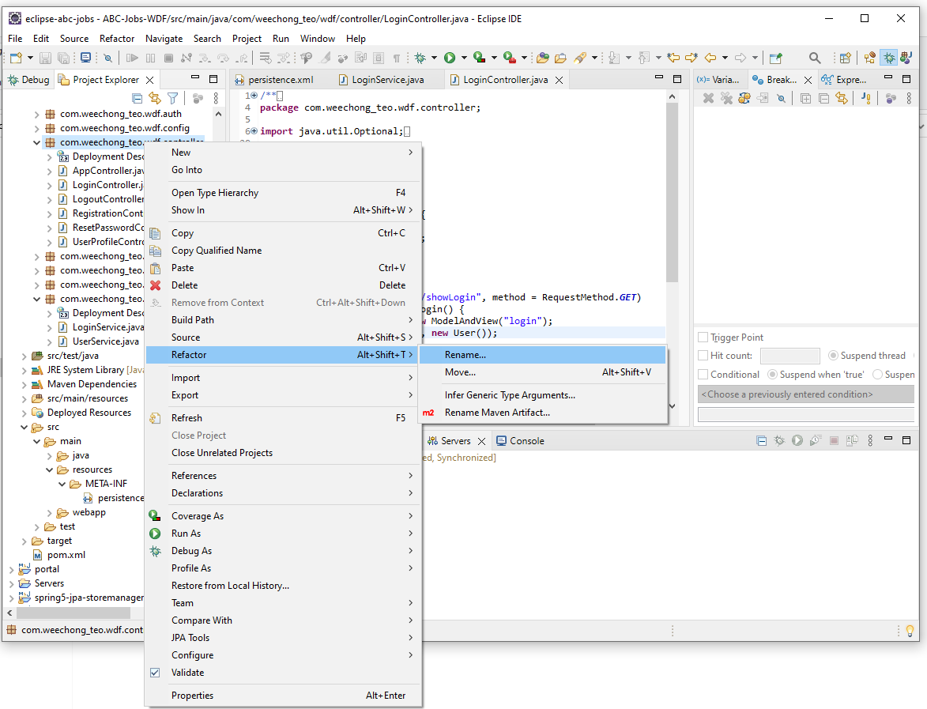

# Task 4

**Task Statement:**

Create the following items in “Coding & Documentation Standards” Section in Project Report

1. List 5 Coding Standards & Conventions to be used and explain shortly.
2. Describe briefly documentation tool, you will be using and its configuration.

**Solution:**

## Coding Standards & Conventions

Naming conventions make programs more understandable by making them easier to read. They can also give information about the function of the identifier and can be helpful in understanding the code.

| Identifier Type | Rules for Naming | Examples |
| --- | --- | --- |
| Packages | The prefix of a unique package name is always written in all-lowercase letters and should be one of the top-level domain names.  Subsequent components of the package name vary according to project requirements. Such conventions might specify that certain directory name components be project, functions, or other names. | com.weechong_teo.wdf.entity  com.weechong_teo.wdf.controller |
| Classes | Class names should be nouns, in mixed case with the first letter of each internal word capitalized. | class User  class UserProfile |
| Interfaces | Interface names should be capitalized like class names. | interface EducationRepository |
| Methods | Methods should be verbs, in mixed case with the first letter lowercase, with the first letter of each internal word capitalized. | getPassword()  setPassword() |
| Variables | Except for variables, all instance, class, and class constants are in mixed case with a lowercase first letter. Internal words start with capital letters. | username  password |

## Javadoc

Javadoc is a documentation generator for the Java language for generating API documentation in HTML format from Java source code.

The basic structure of writing document comments is to embed them inside /** ... */.

### Class Declaration

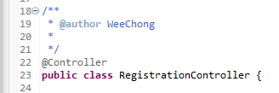

### Method

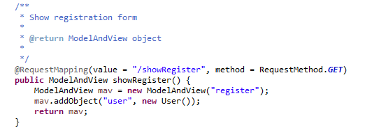

### Variables

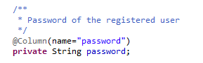

# Task 5

**Task Statement:**

1. Develop the following pages in HTML (Developed in Module 3)
   1. Home Page
   2. Create / Edit Page
   3. Listing Page
   4. Login / Logout pages
   5. Forget Password screen
   6. Administration Page
2. Templatize them by separating Headers / Footers and including them using Server Side includes.
3. Provide the screen capture in Project Presentation

**Solution:**

## Home Page

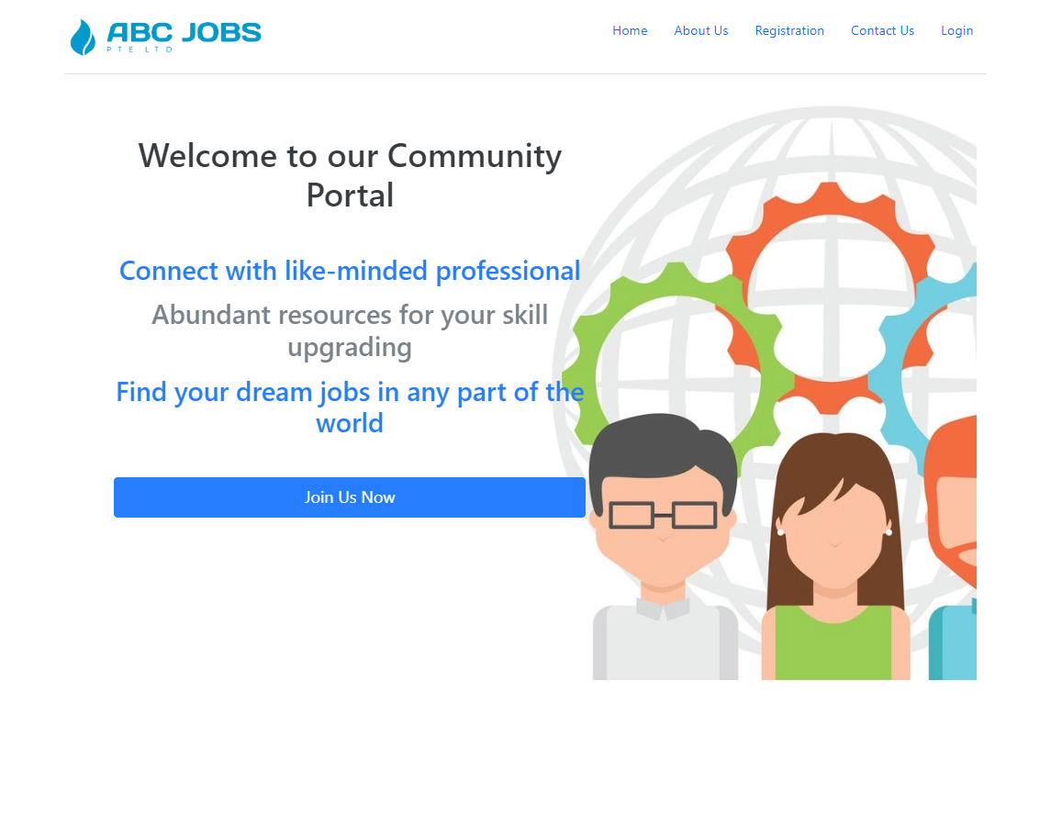

## Create/Edit Page

### Registration

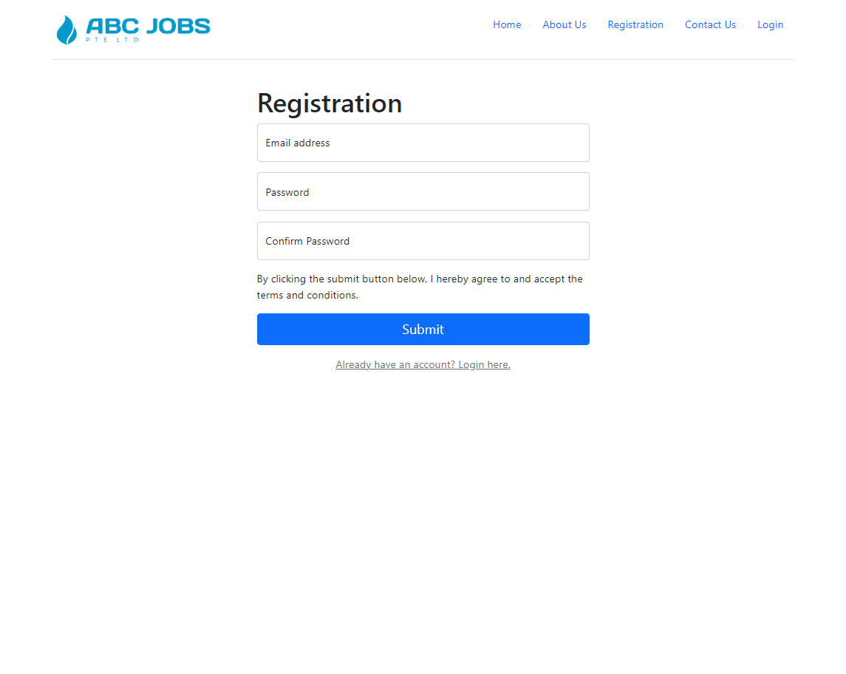

### Update Profile

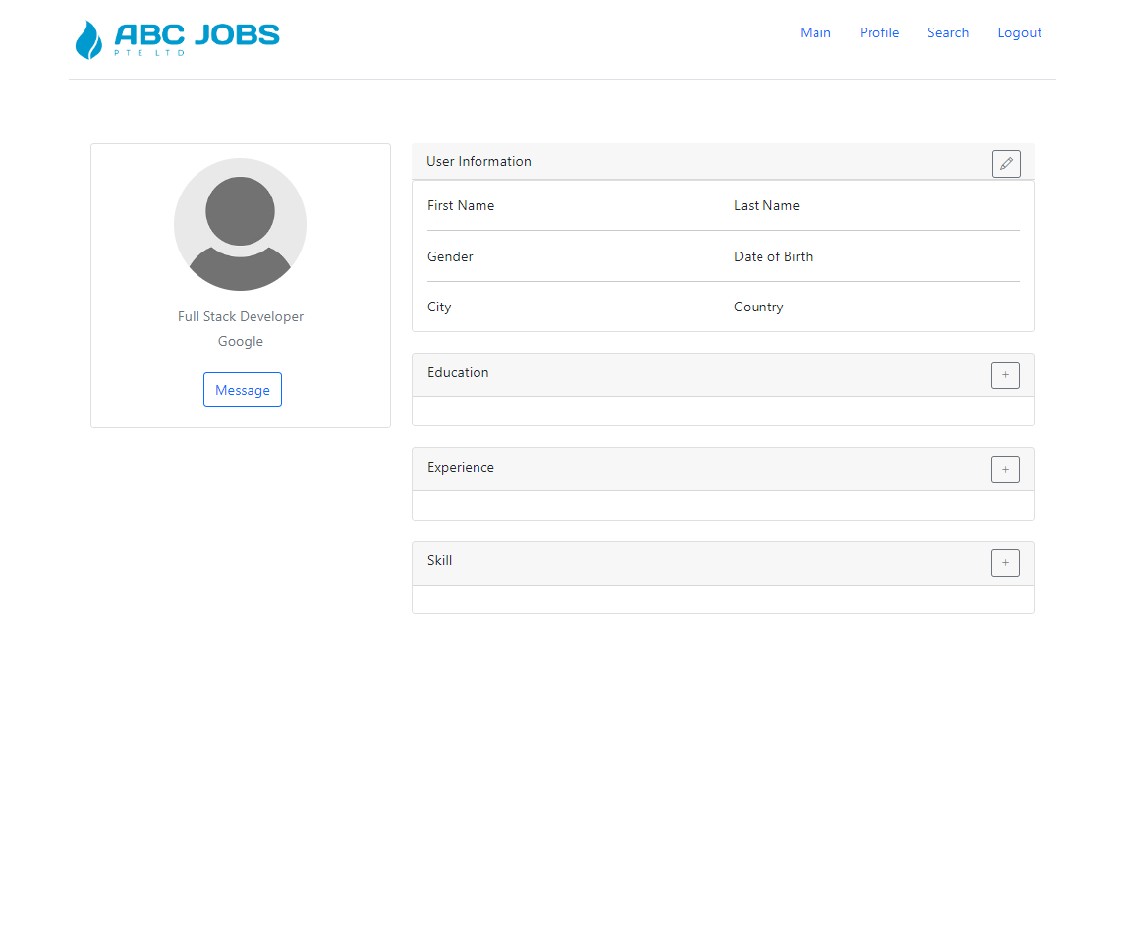

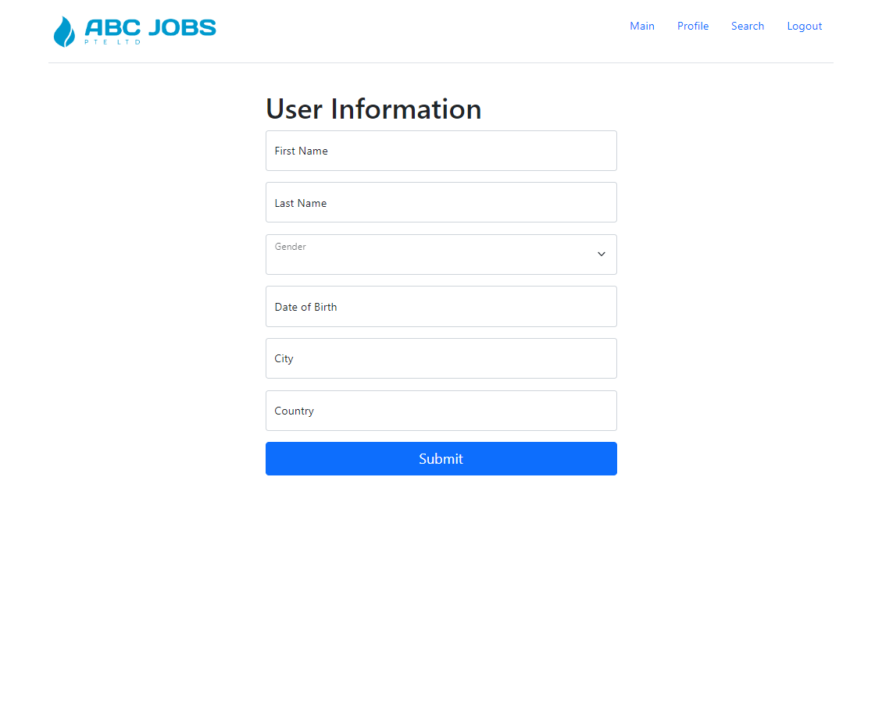

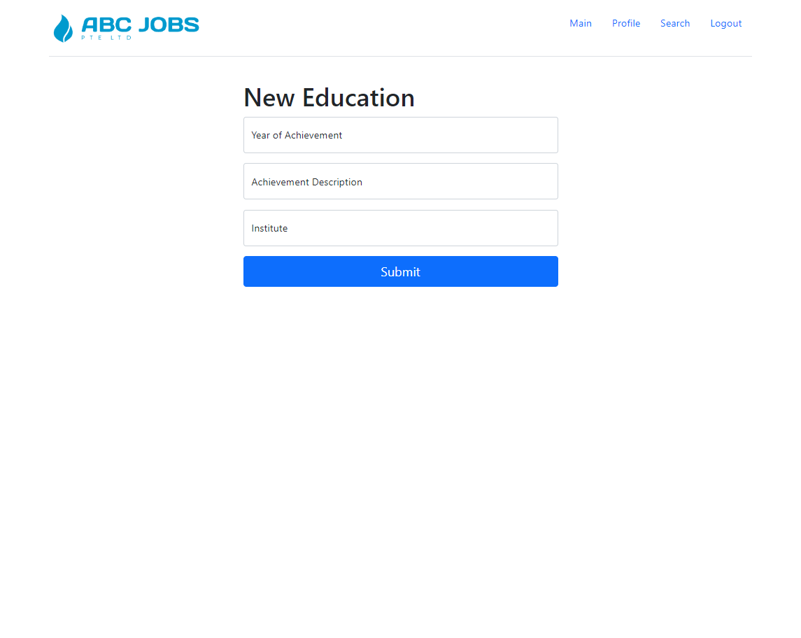

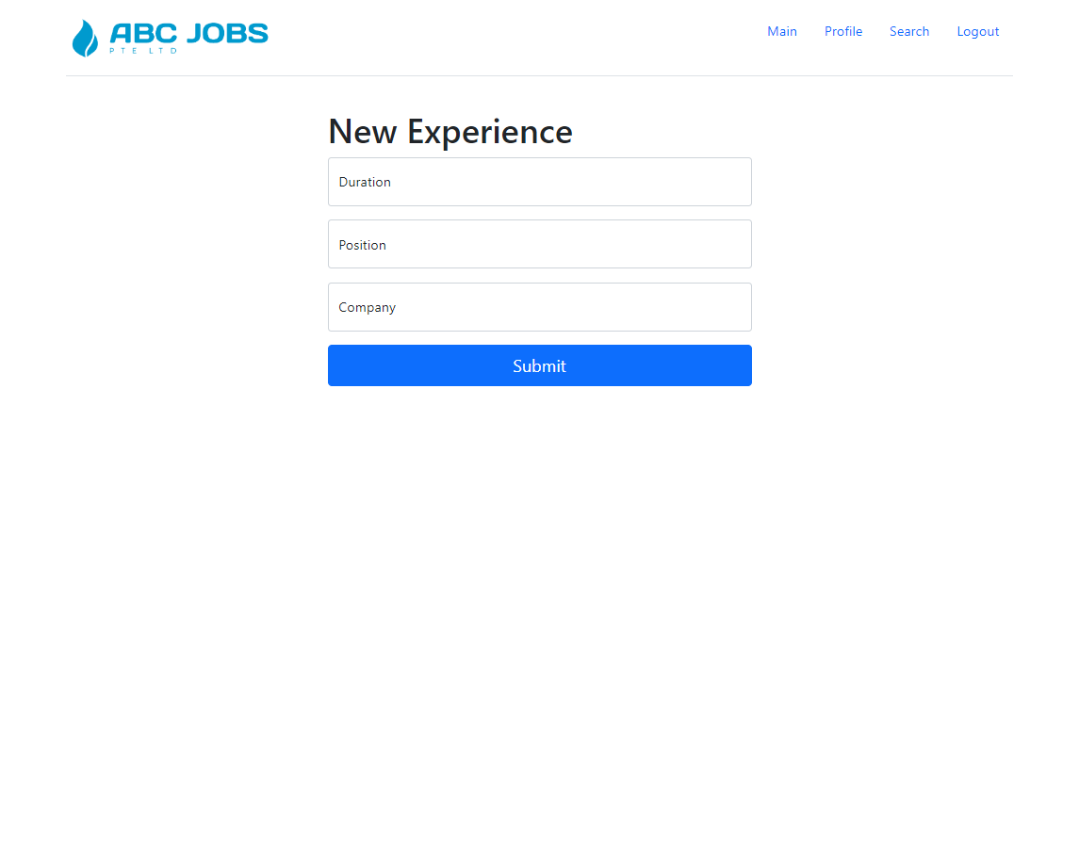

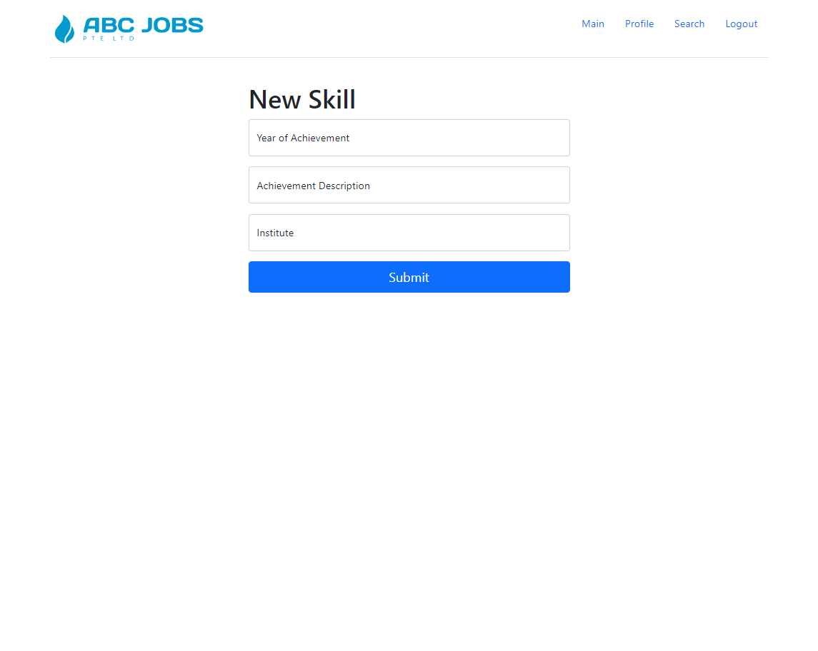

## Listing Page

### Search

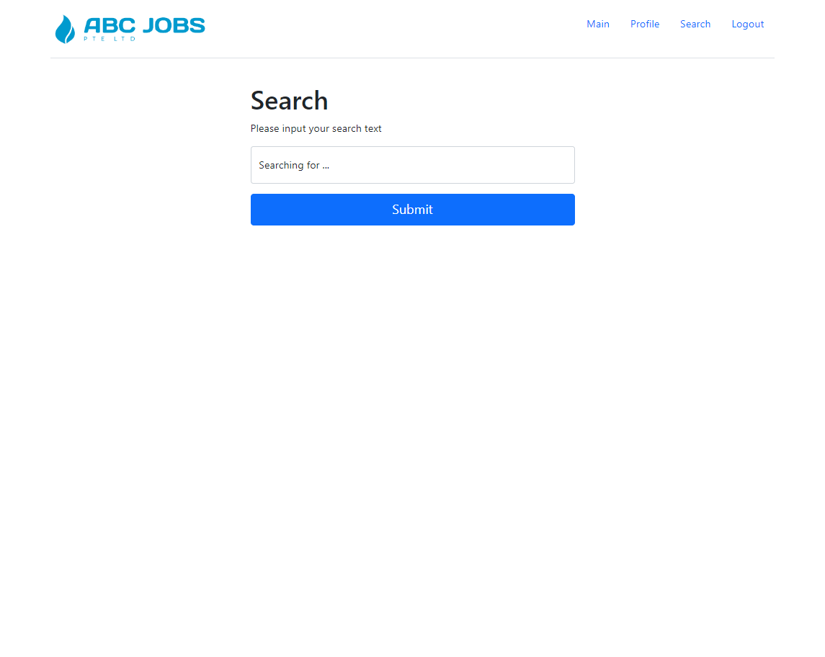

## Login/Logout Page

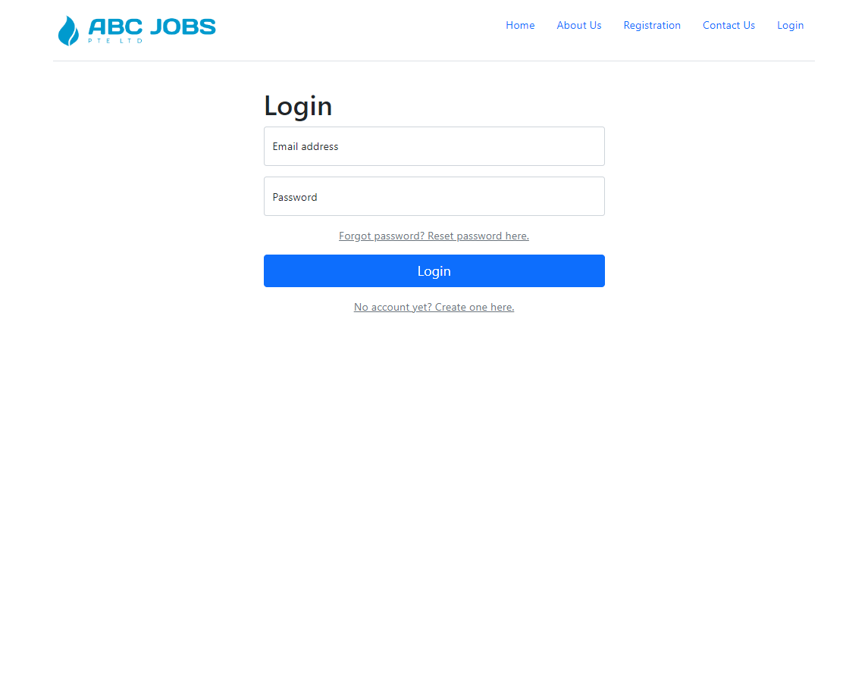

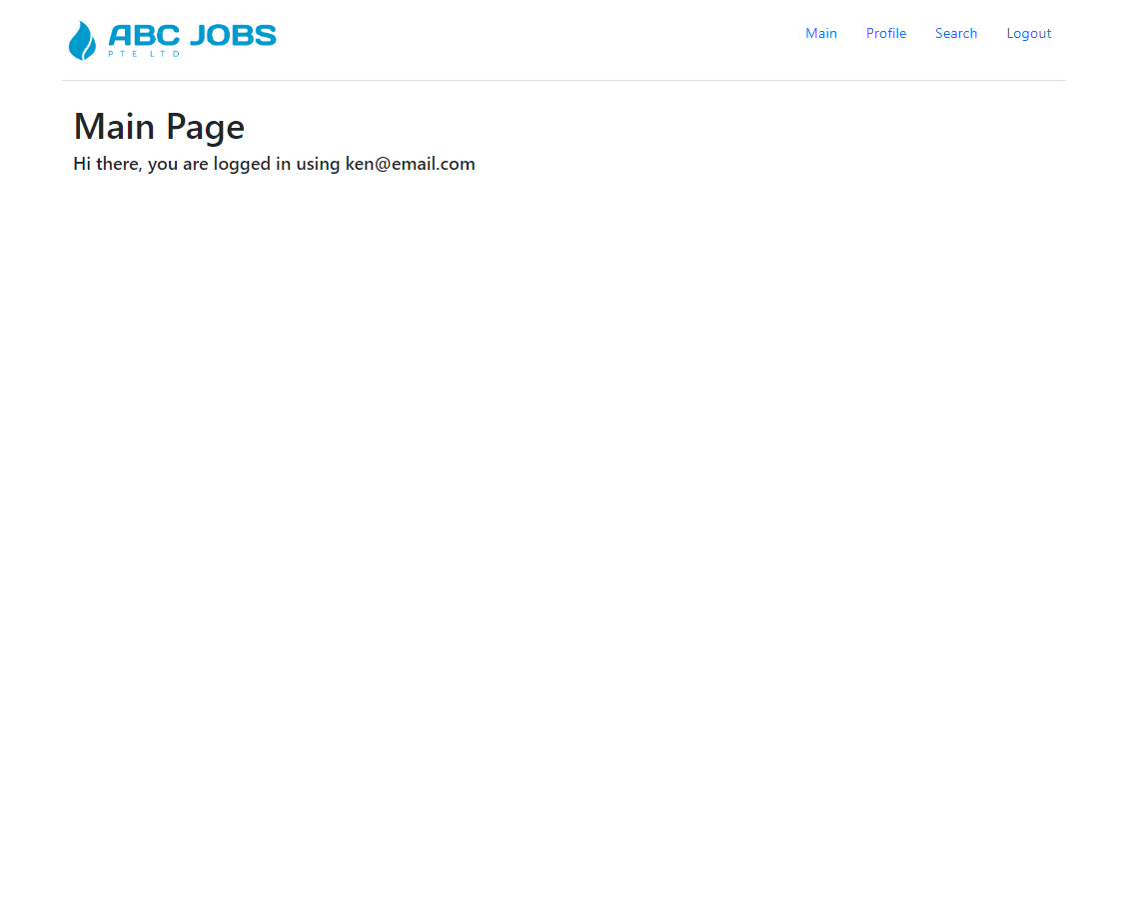

## Forget Password Page

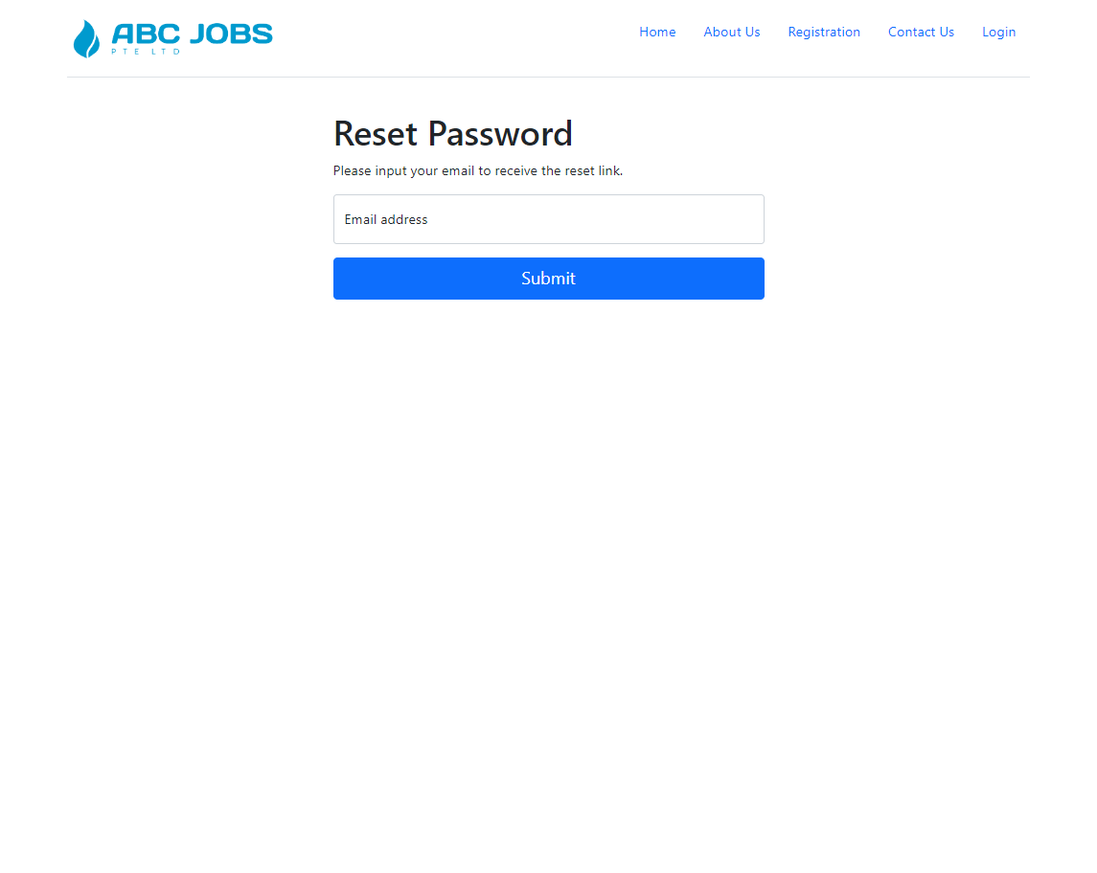

## Administration Page

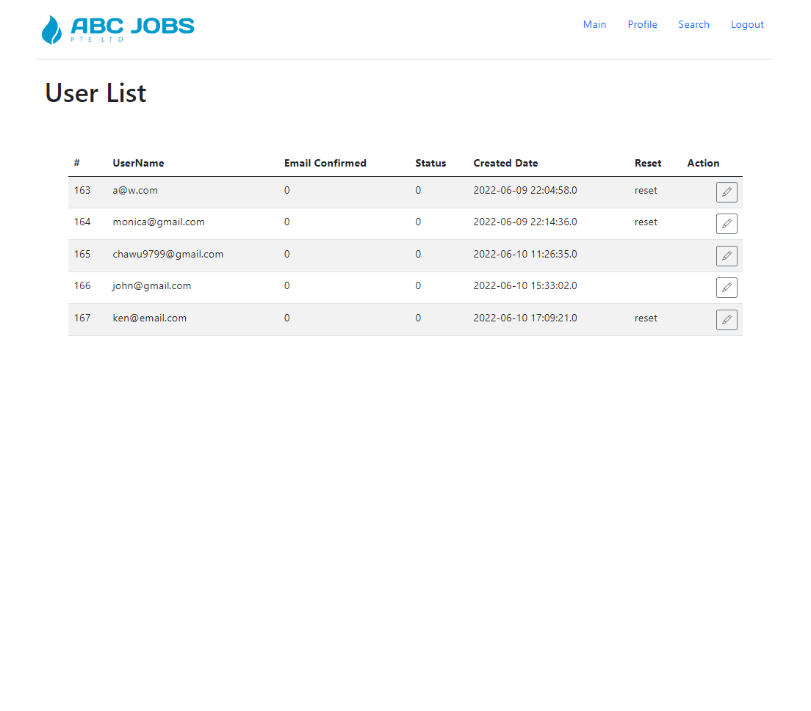

# Task 6

**Task Statement:**

1. Create the required classes in Java
2. Include Data Access Layer classes
3. Include samples as part of Project Report

**Solution:**

## Java Packages and Classes

### Controller Classes

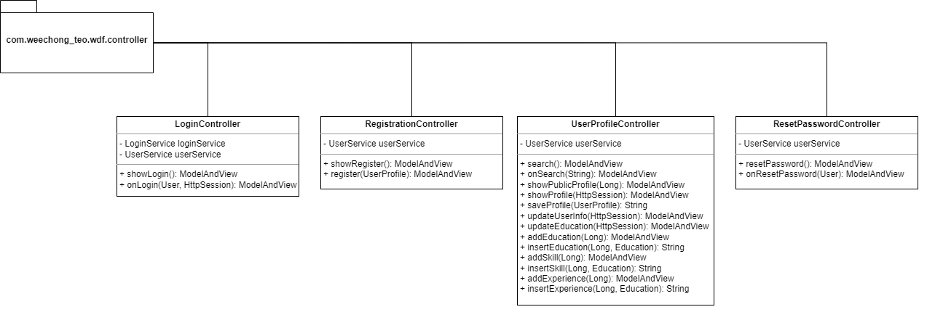

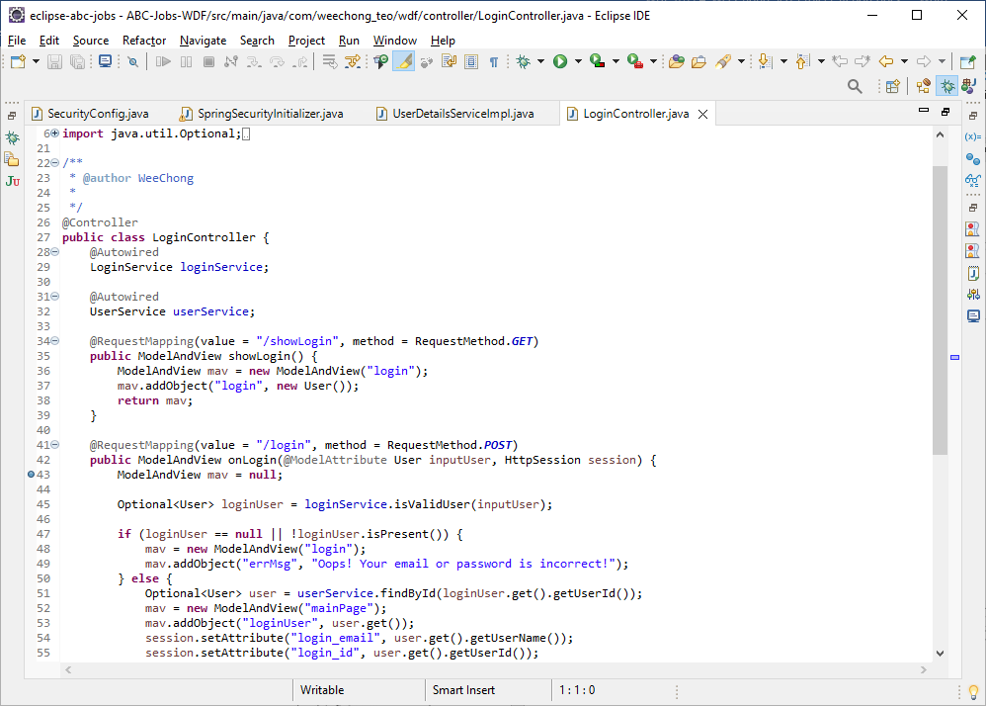

### Service Classes

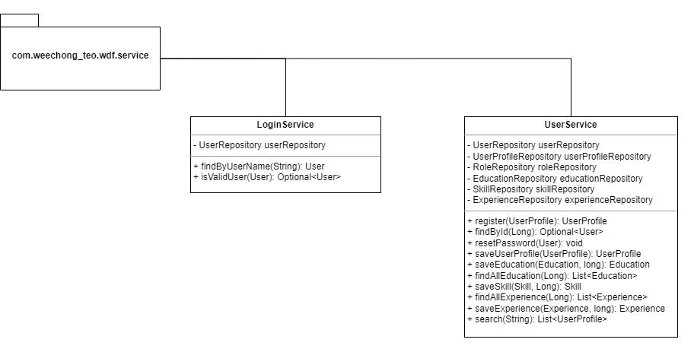

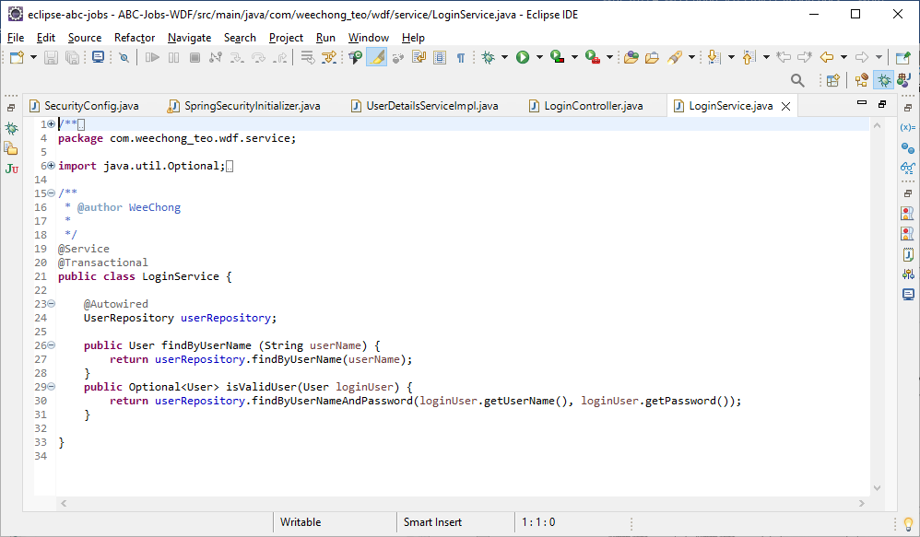

### Entity Classes

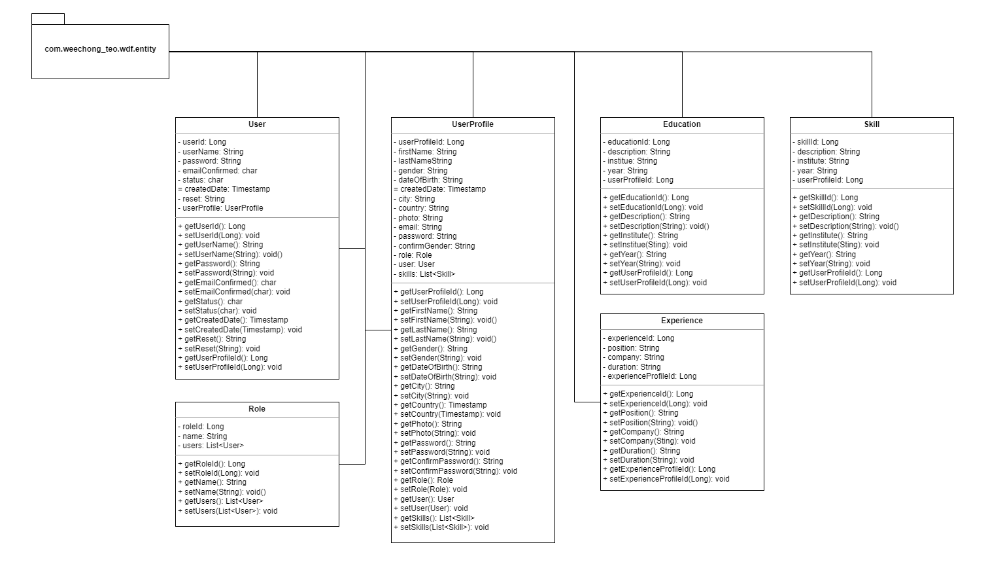

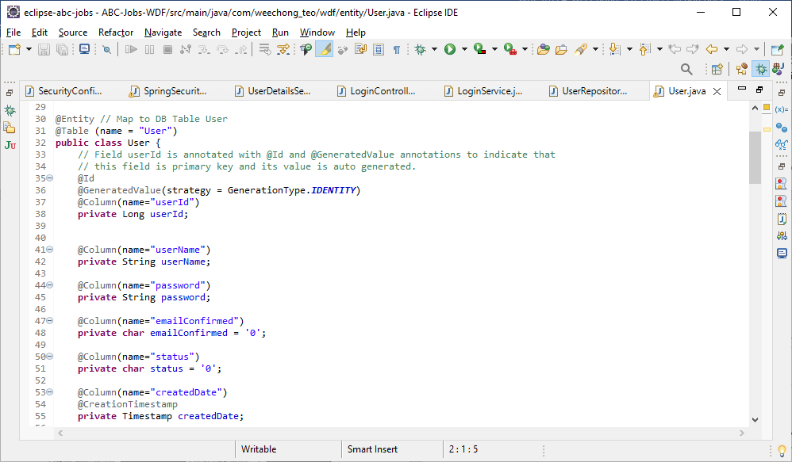

### Repository Classes

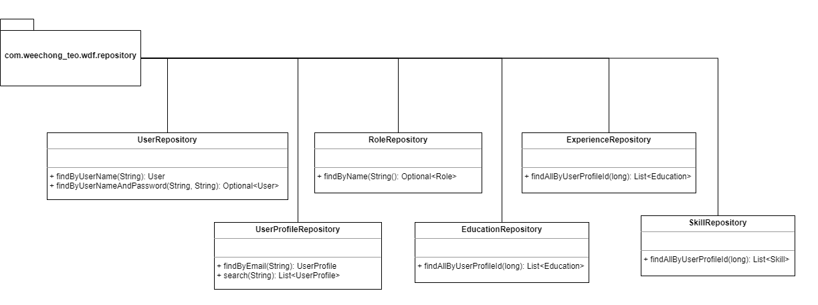

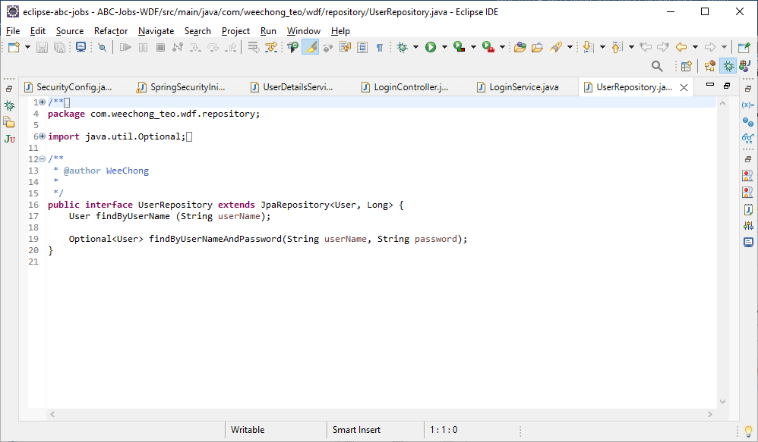

# Task 7

**Task Statement:**

Provide screen capture of developed pages and hosted application in Project Presentation

1. Use Queries, Procs Developed in Module 4
2. Develop the Models, Views, Controller (at least for one of the functionalities, better if you can use for all the functionality)
3. Develop Home Page & Integrate with Login System
4. Develop Registration Form & Registration Thank You
5. Develop Forget Password mechanism
6. Develop Landing Page post login
7. Develop Search Box for Users
8. Develop View Search Results
9. Develop View Profile Page
10. Develop Edit Profile Functionality

**Solution:**

## Registration

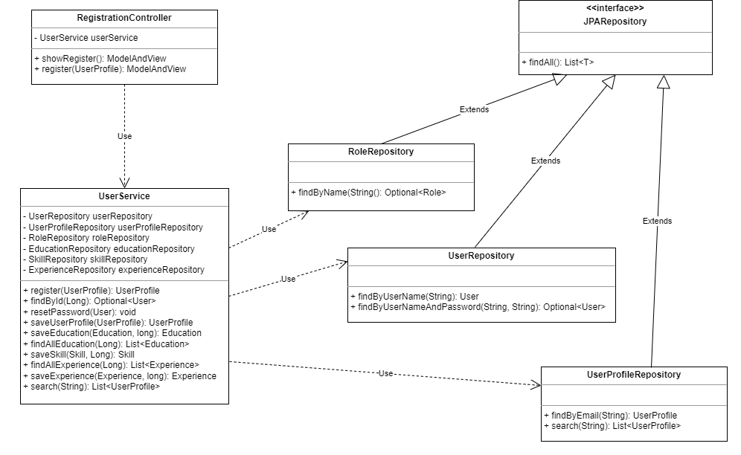

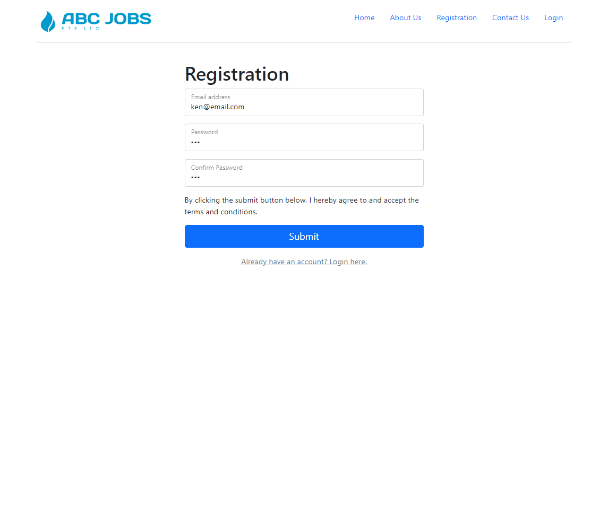

Register with following information.

Email: ken@email.com

Password: 123

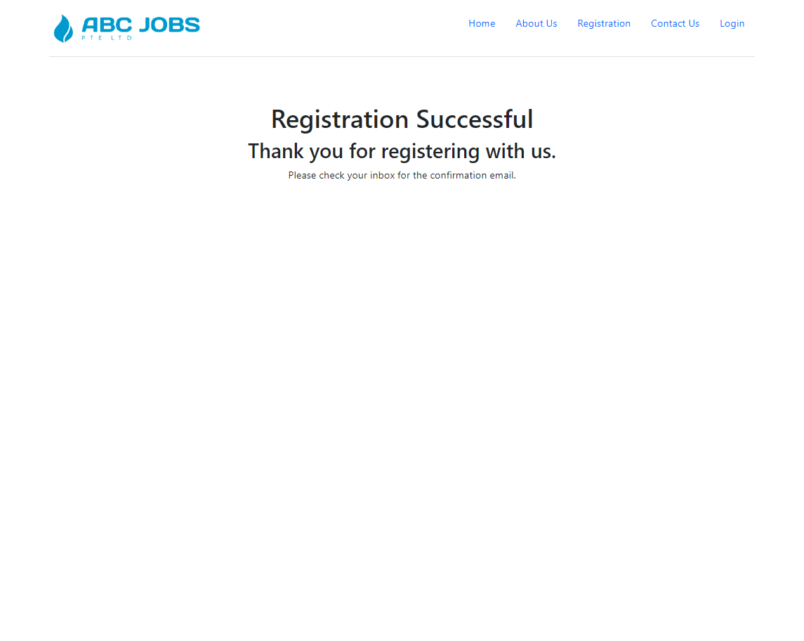

Registration successful message is displayed to notify the completion of registration.

## Login

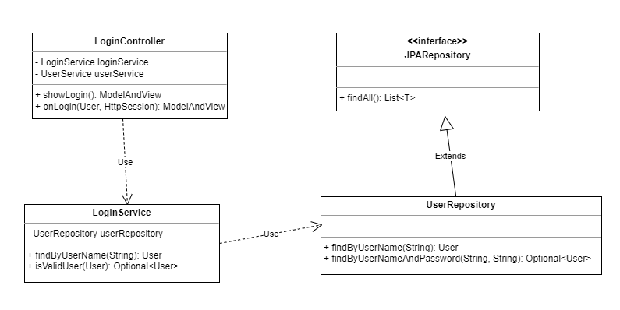

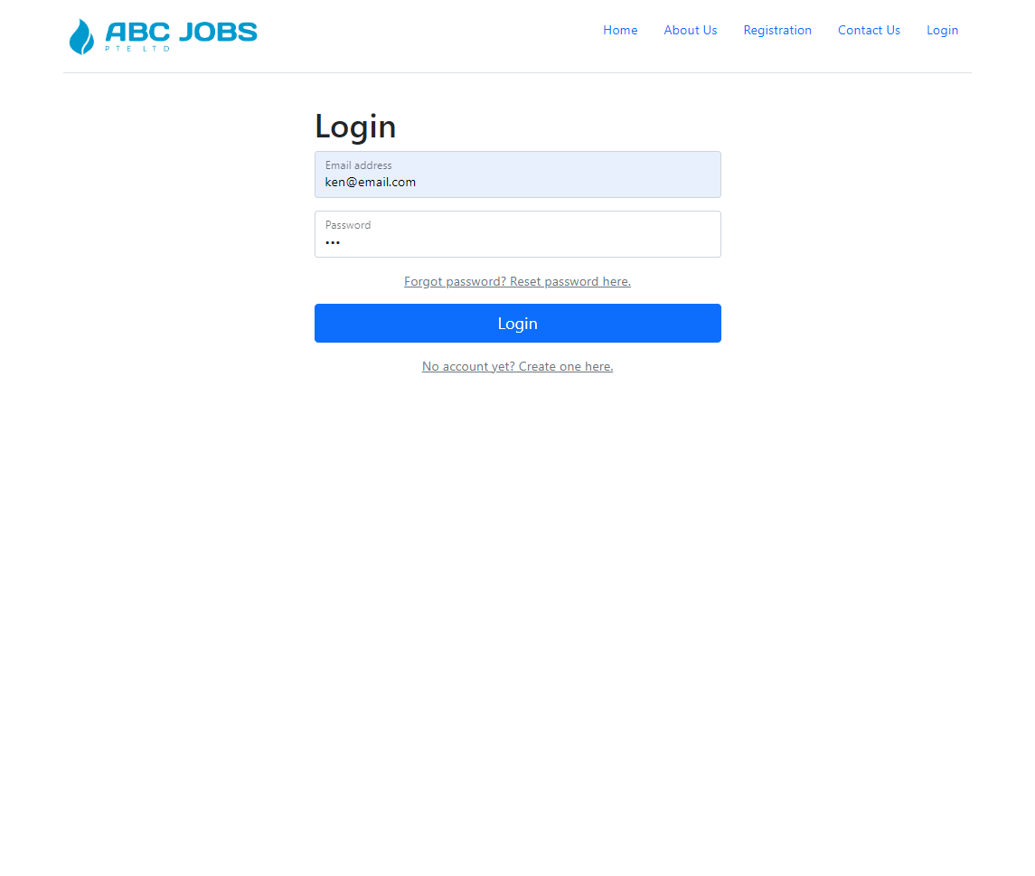

Login using [ken@email.com](mailto:ken@email.com) with password 123.

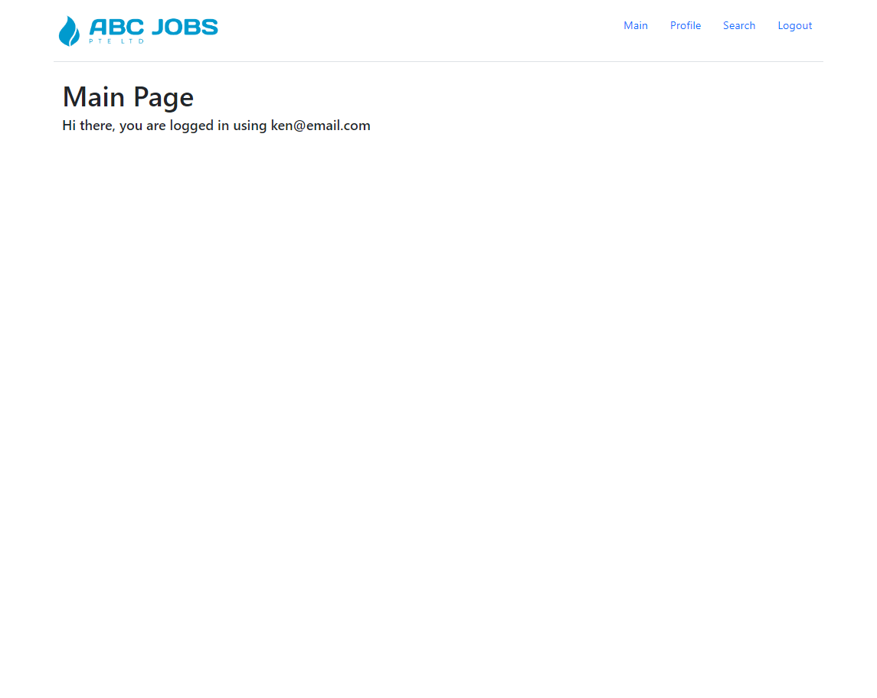

Successful login will proceed to the Main page as shown above.

## Reset Password

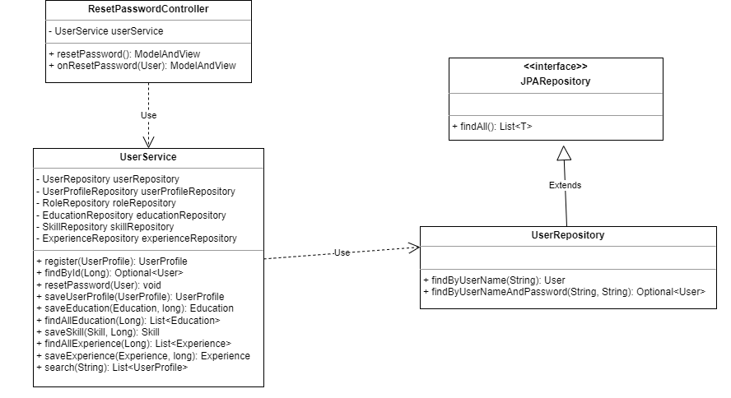

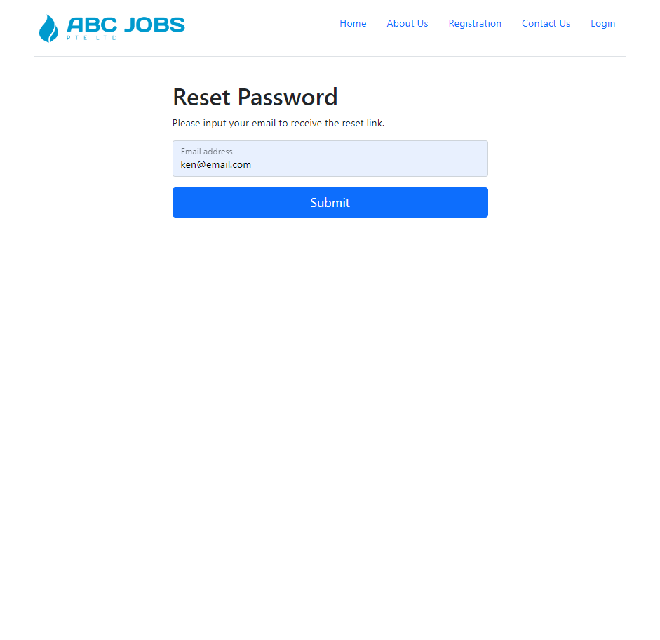

Reset with [ken@email.com](mailto:ken@email.com).

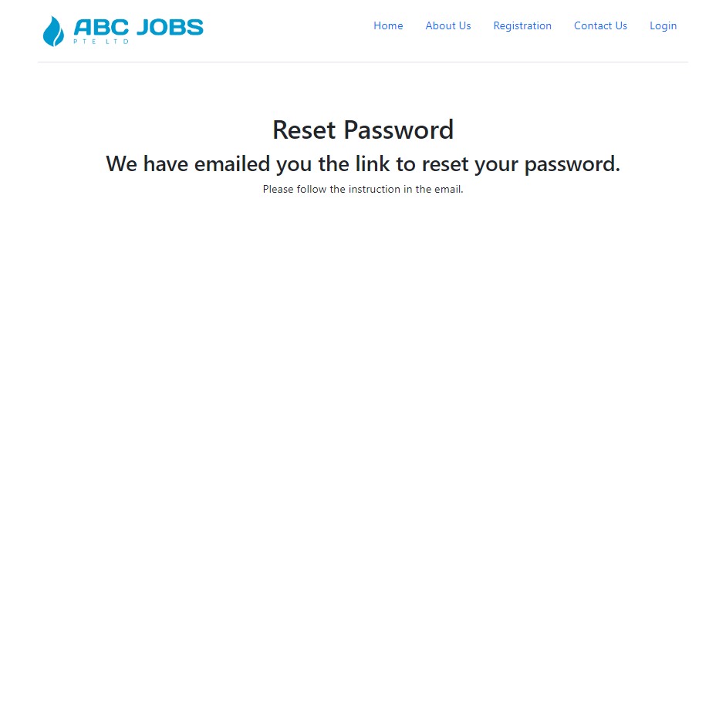

Reset successful message.

## Search

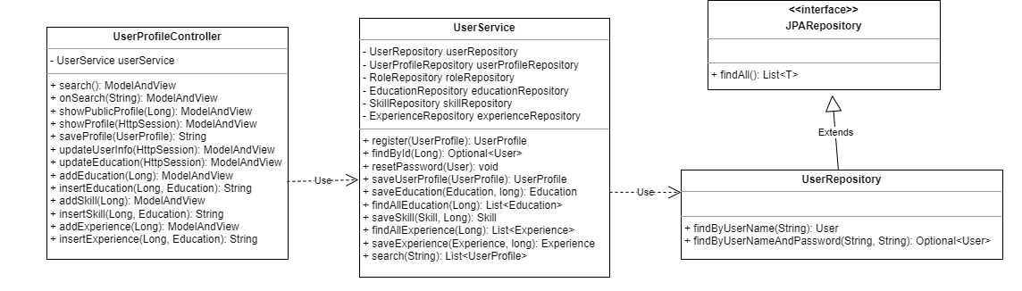

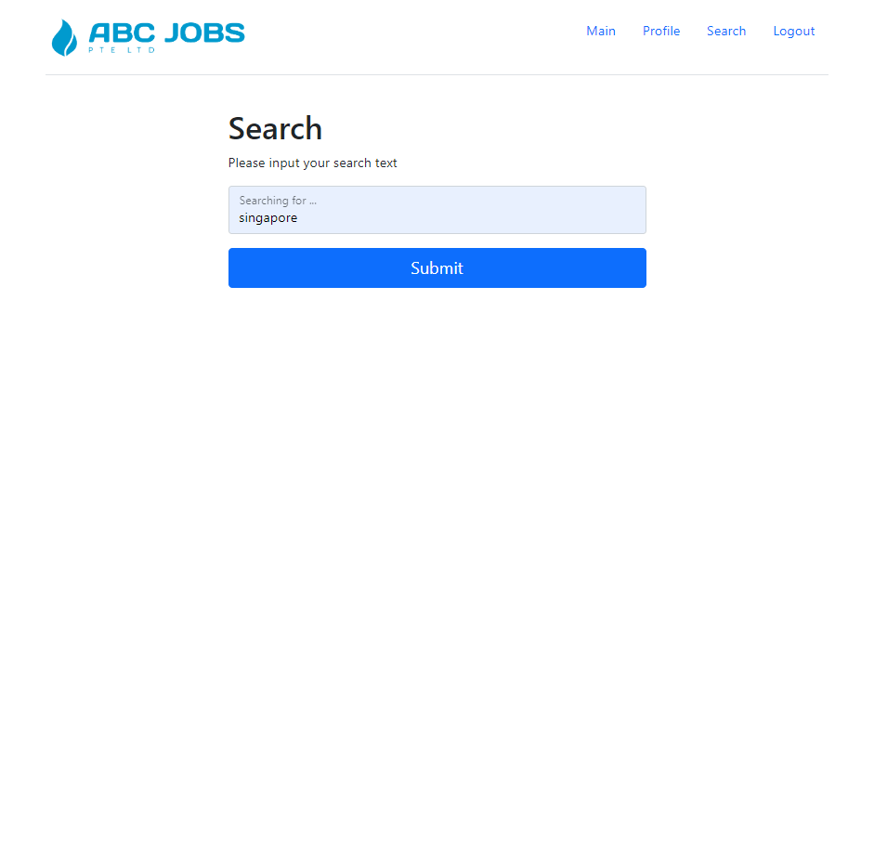

Search using Singapore as search text.

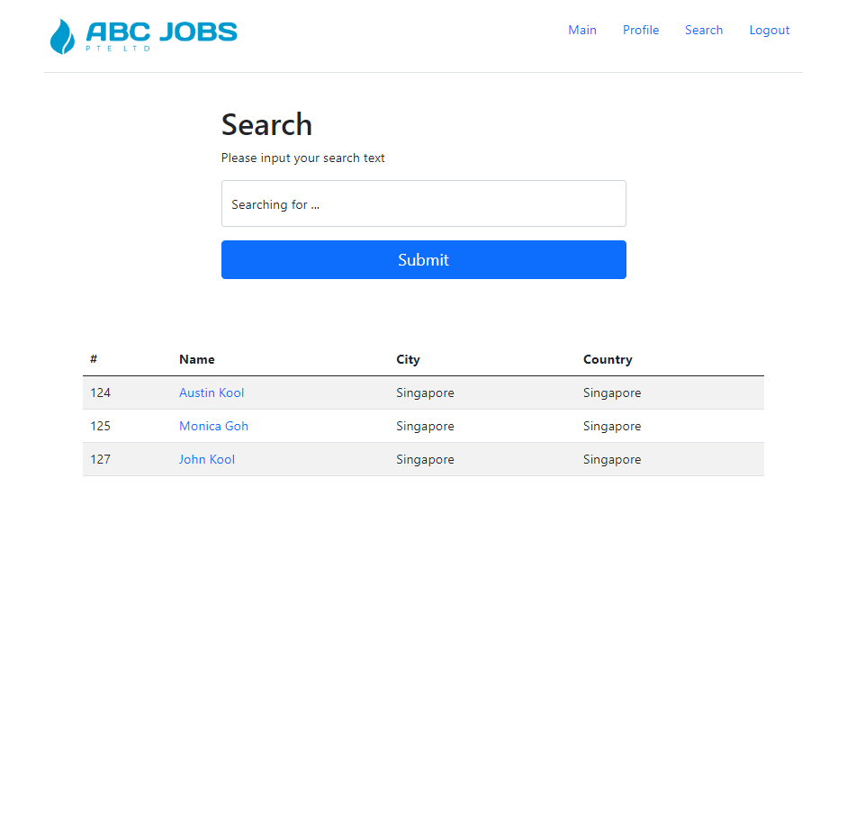

Search result screen.

## View Profile

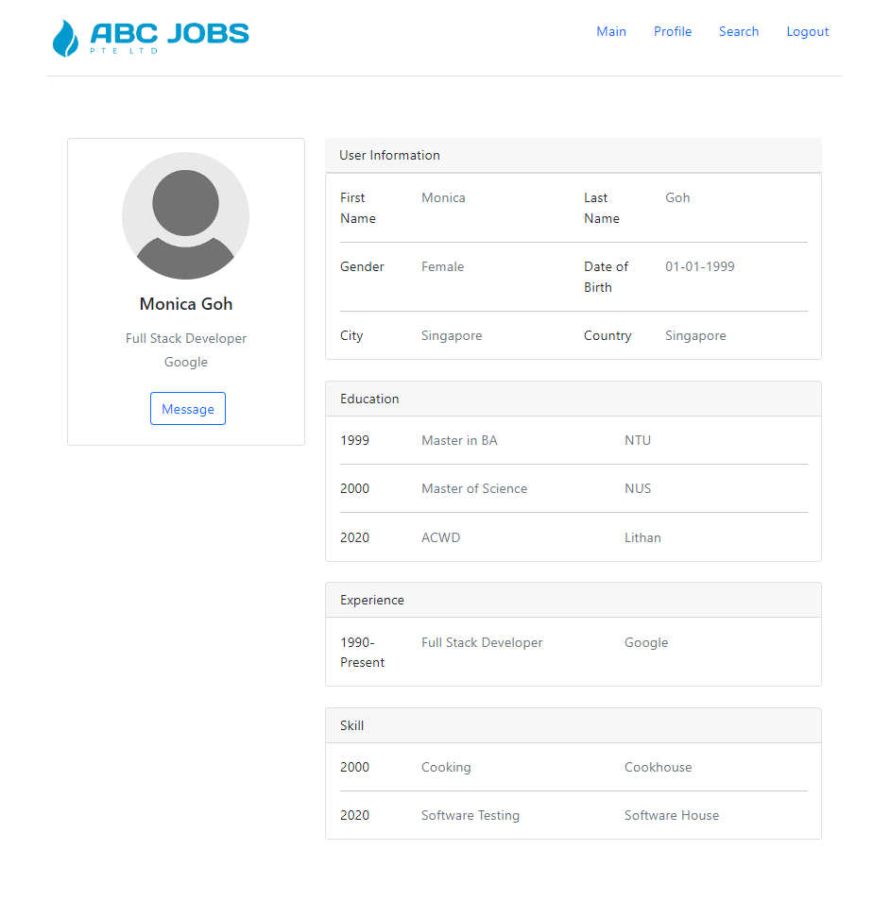

## Update Profile



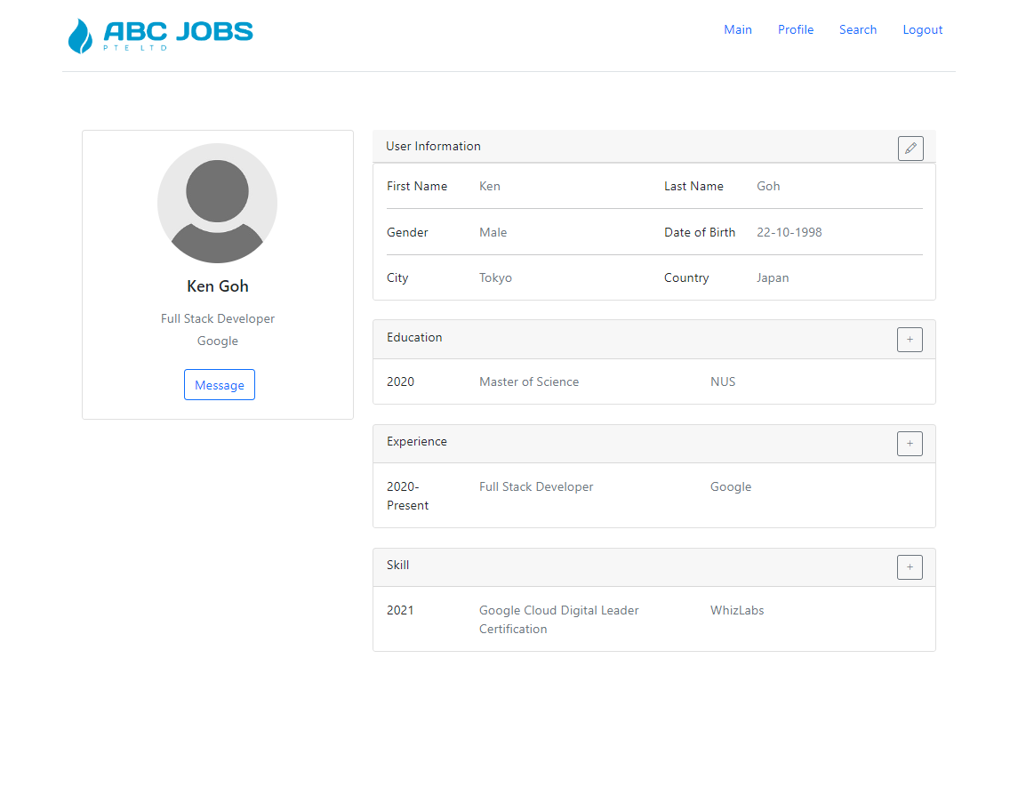

### Update User Information

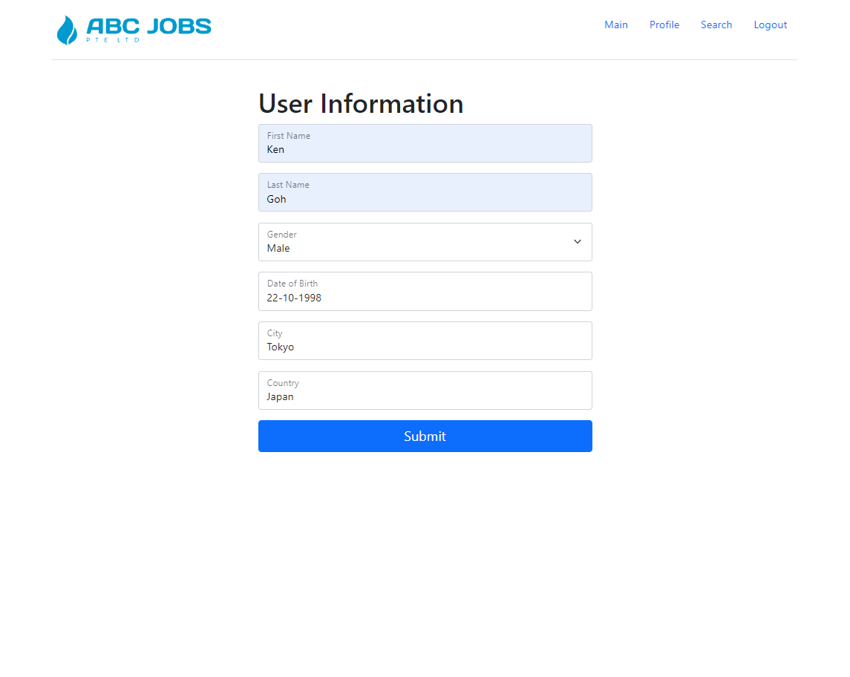

### Add Education

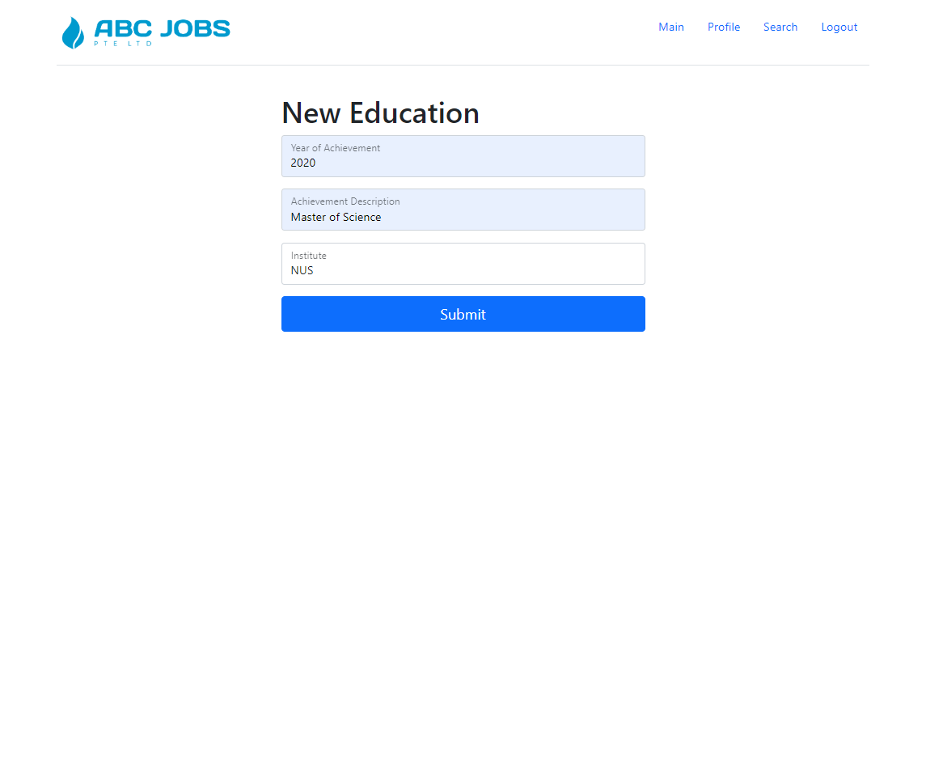

### Add Experience

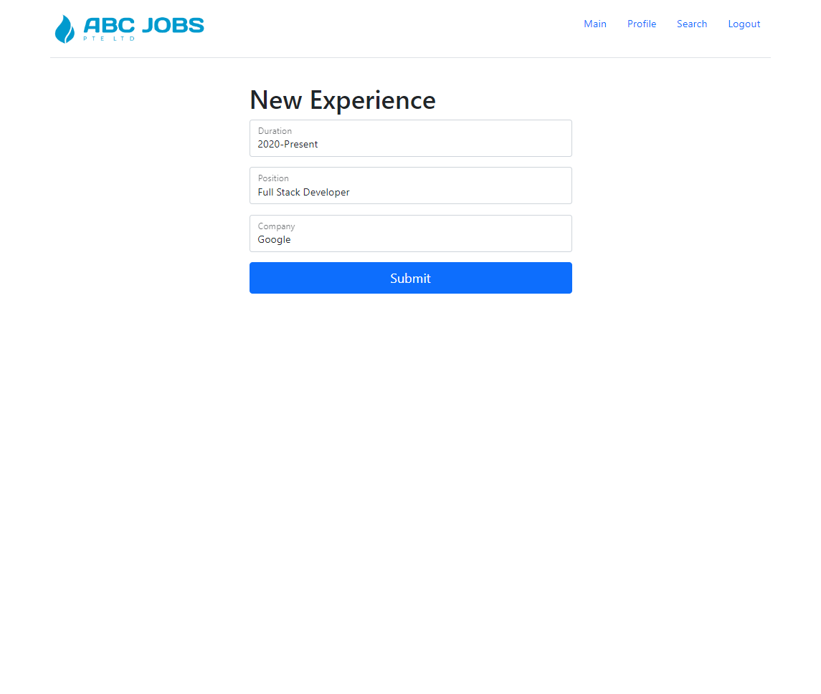

### Add Skill

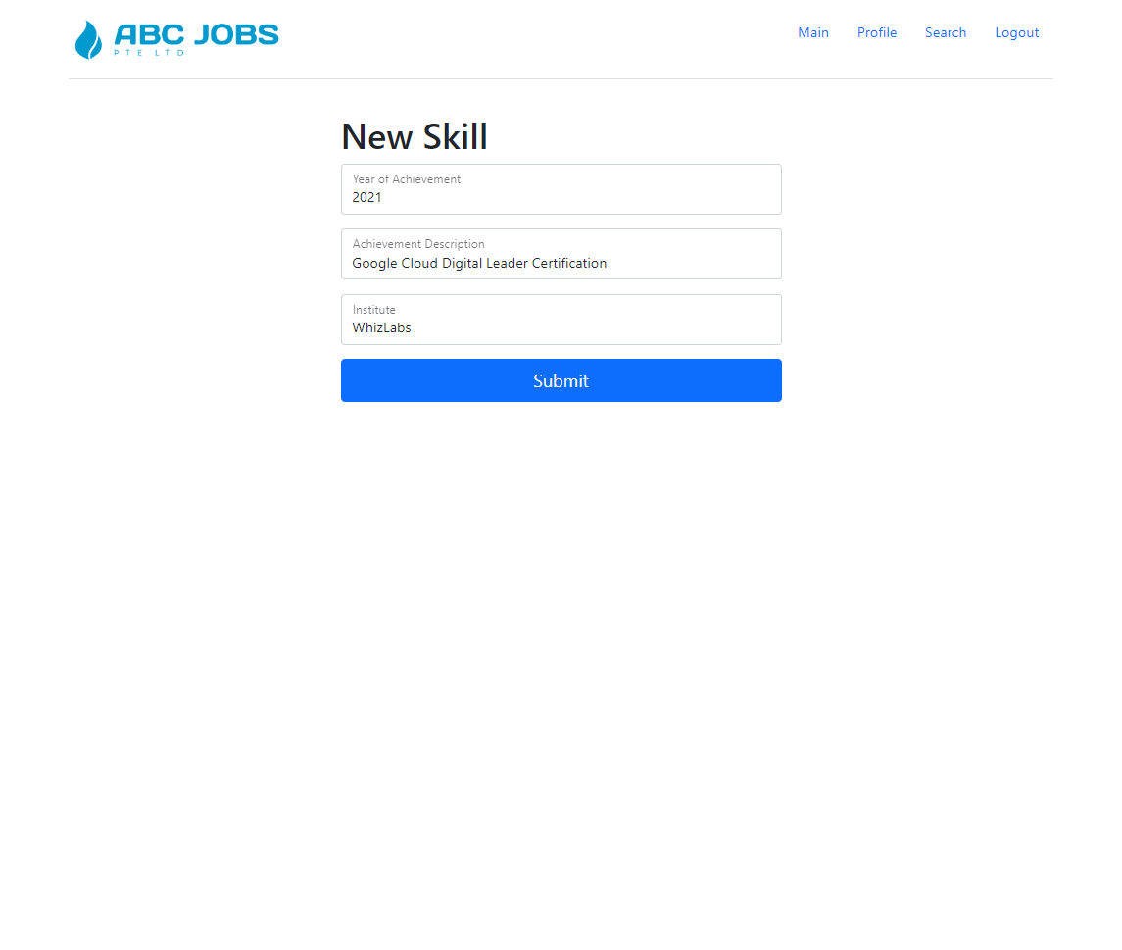

# Task 8

**Task Statement:**

1. Debug the application in Eclipse
2. Provide the screen capture of your application code in Eclipse Debug Mode include it as part of Project Presentation

**Solution:**

## Starting the Debugger

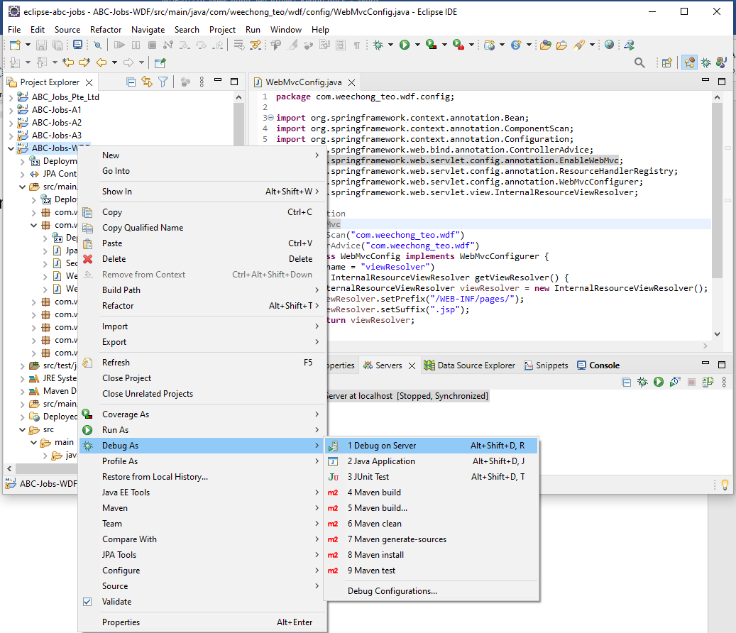

## Set Breakpoints

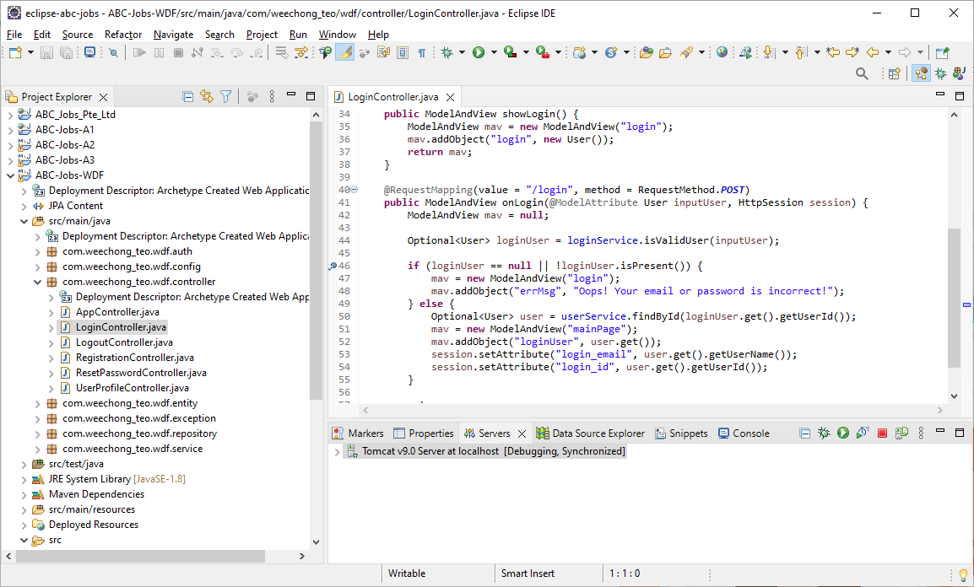

## View Variables

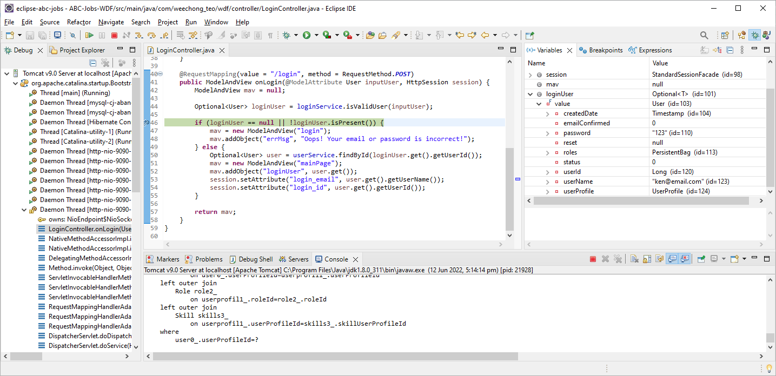

# Task 9

**Task Statement:**

1. Provide screen capture of 3 Errors you encountered while developing the application.
2. How did you handle those 3 errors (Write in short bullet points)
3. Include it as part of Project Presentation

**Solution:**

## Incorrect Persistence Configuration

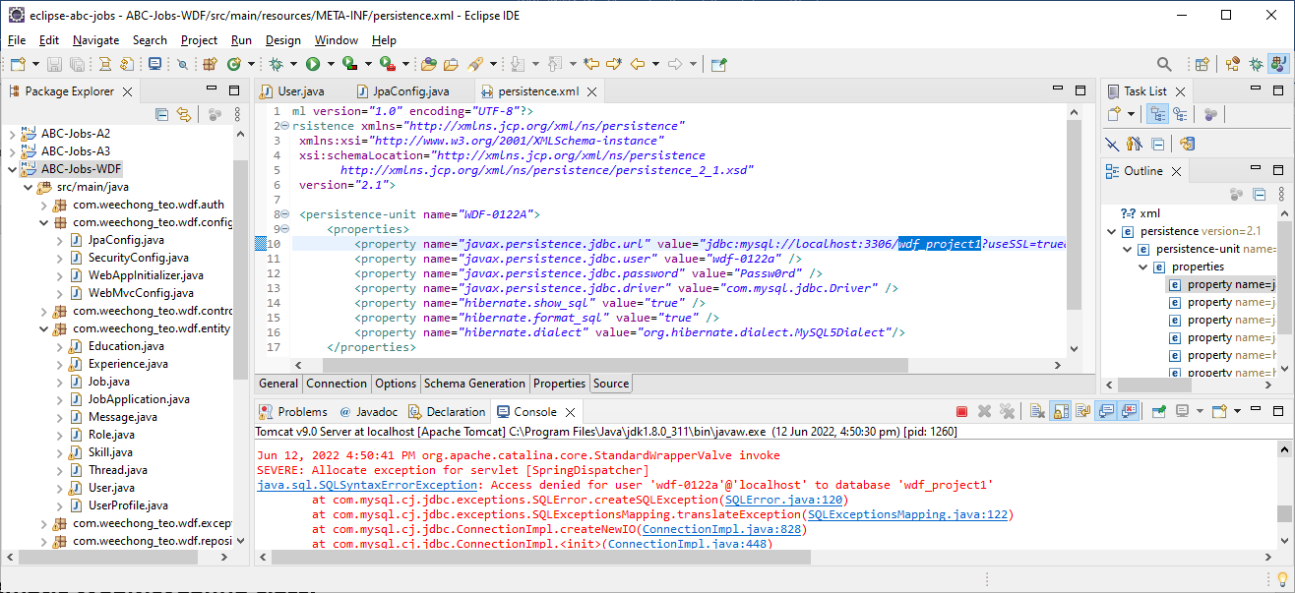

The name of the database was incorrectly configured in the *persistence.xml*.

Changing the database name to the correct name resolve the problem.

## Incorrect Persistence Provider

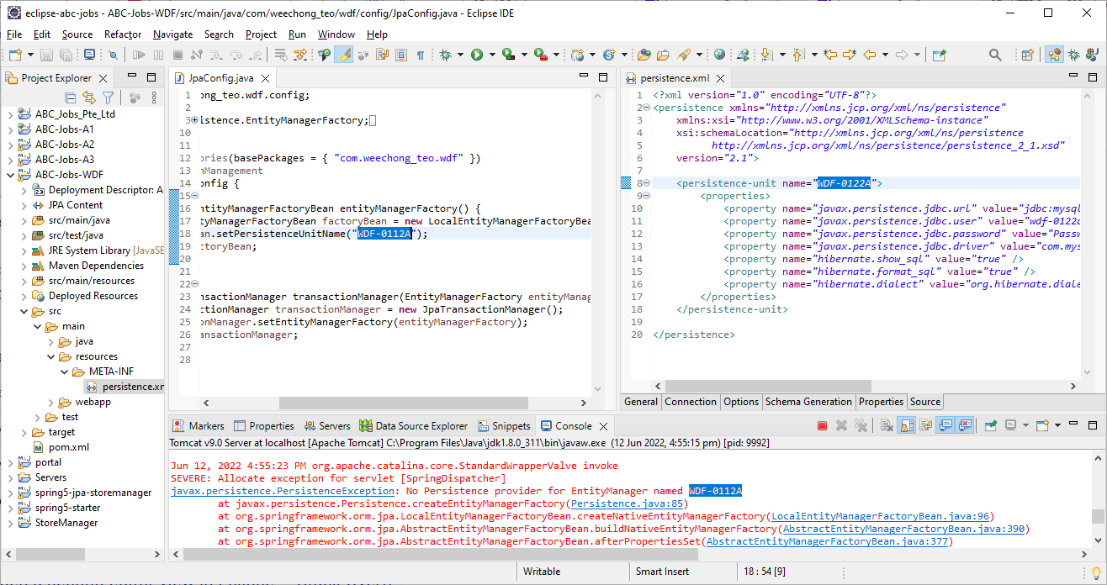

Due to typo error, the Persistence provider cannot be connected.

Update the following line in *JpaConfig.java* file resolved the problem.

factoryBean.setPersistenceUnitName("WDF-0122A");

## Unable to load static resources

Static image such as the logo is not displayed as shown below.

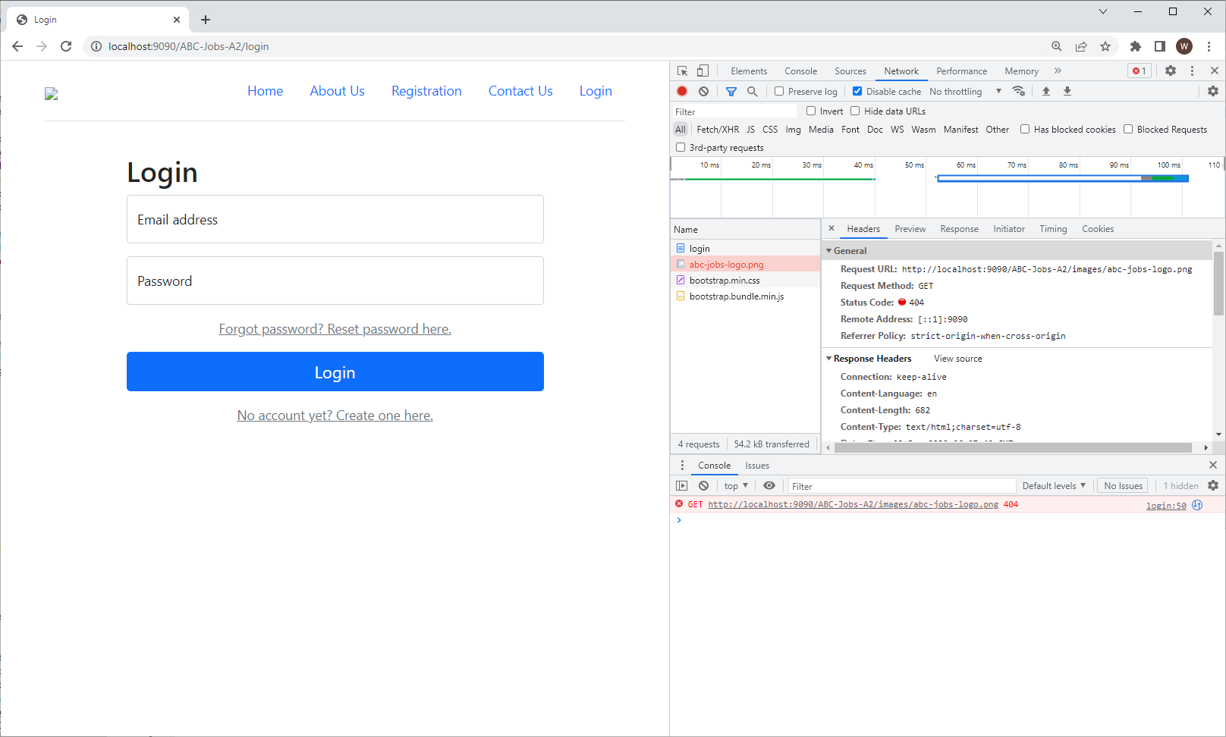

**Fixes to *WebMcvConfig* class.**

The solution is to add the annotation *@EnableWebMvc* to *WebMvcConfig* *@Configuration* classes in order to enable MVC Java configuration.

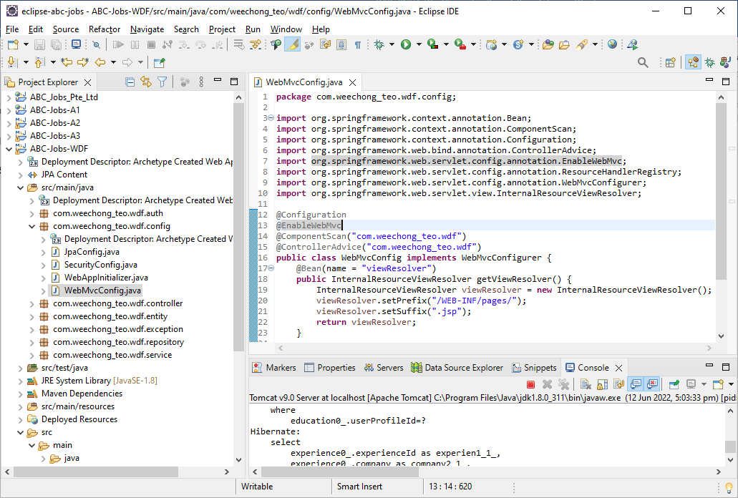

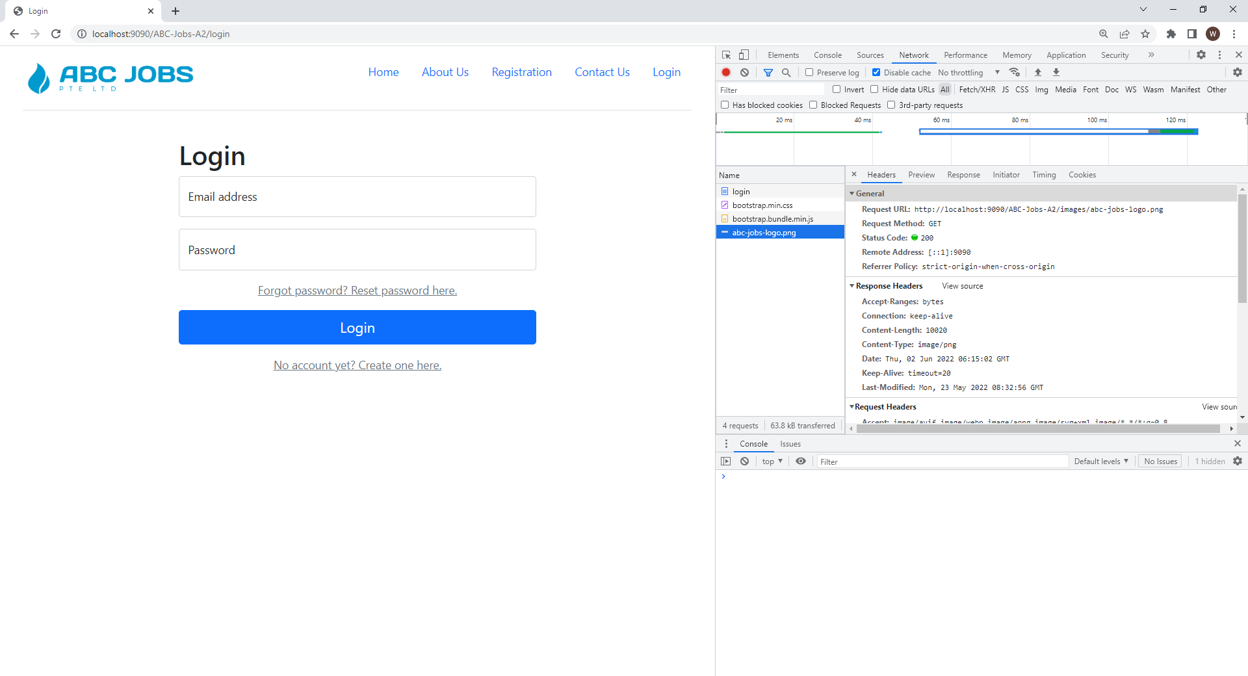

# Task 10

**Task Statement:**

1. Propose & Document a new feature to the application
2. Develop the new feature and provide a report.
3. Include it as part of Project Report

**Solution:**

## Alert Notification

An alert notification feature can be added to the system. This notification module can notify user the following events.

1. A new message has been received
2. A new thread has been posted
3. A new job posting has been placed
4. A new status to the user’s job application

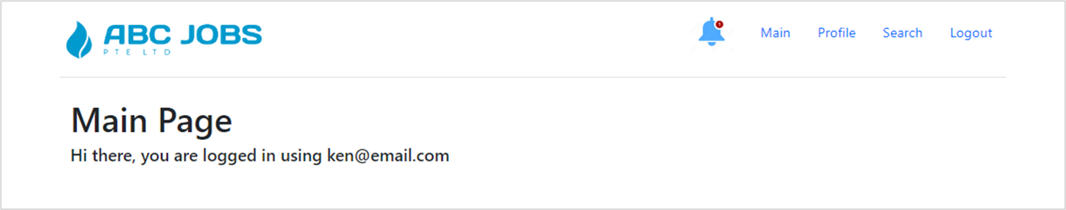

The notification bell icon is to located at the navigational bar with a number to indicate the number of notifications. Clicking on the bell icon will open the list of alerts.

# Task 11

**Task Statement:**

Provide Unit Testing code & screen capture of Eclipse IDE in debug mode.

1. Develop and execute unit testing for individual modules (At least 3 Cases)
2. Create Test Cases for the Individual Modules (At least 3 cases in total) and document it in Project Report
3. List the bugs and document in Project Report
4. Fix the bugs as needed
5. Deploy to Lithan servers

**Solution:**

## Unit Testing

### LoginServiceTest

1. testInvalidUserName – To test for invalid user name.
2. testInvalidUser – To test for invalid credential.
3. testValidUser – To test for valid credential.
4. testValidUserName – To test for valid user name.

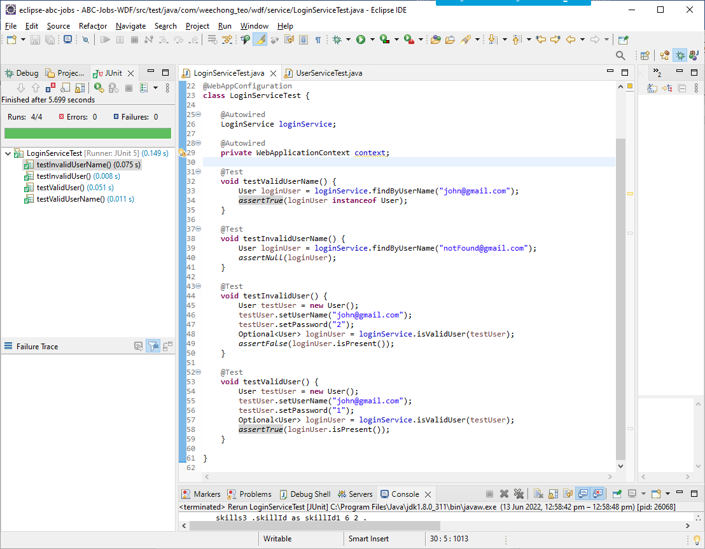

### UserServiceTest

1. testSaveProfile – To test a user profile is created and saved.

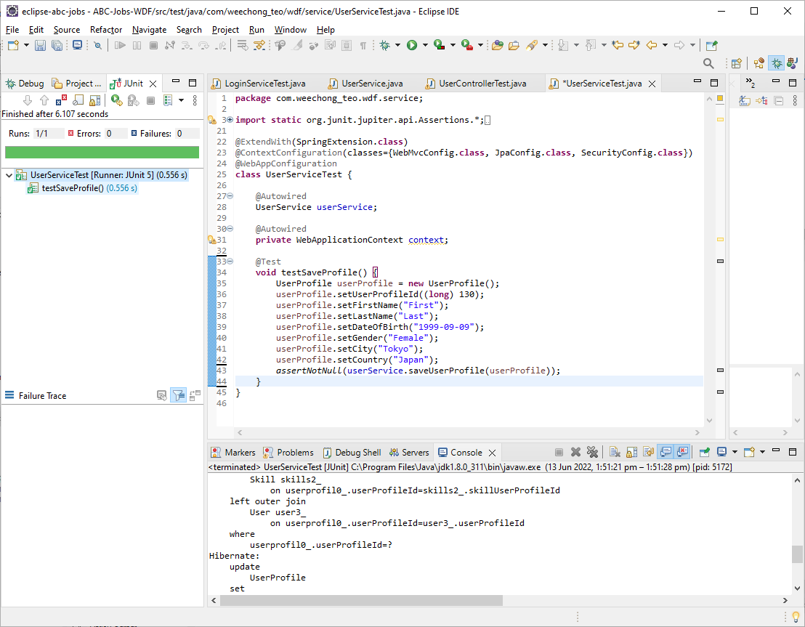

## Test Cases

|  |  |  |  |  |
| --- | --- | --- | --- | --- |
| S/N | Test Case | Expected Result | Actual Result | Outcome |
| 1 | Register with a new email address.  Test data  Email: [soh@email.com](mailto:soh@email.com), Password: 123456 | Successful | Successful | Pass |
| 2 | Register with a new email address.  Test data  Email: [soh@email.com](mailto:soh@email.com), Password: 123456 | Email Already Exists | Email Already Exists | Pass |
| 3 | Login with Email: [soh@email.com](mailto:soh@email.com), Password: 123456 | Successful | Successful | Pass |
| 4 | Login with Email: [soh@email.com](mailto:soh@email.com), Password: xxx | Email or password is incorrect | Email or password is incorrect | Pass |

## List of Bugs

|  |  |  |
| --- | --- | --- |
| **S/N** | **Problem** | **Cause and Fix** |
| 1 | Encountered java.sql.SQLSyntaxErrorException. | The name of the database was incorrectly configured in the persistence.xml.  Changing the database name to the correct name resolve the problem. |
| 2 | Encountered javax.persistence.PresistenceException. | Due to typo error, the Persistence provider cannot be connected.  Update the correct name in JpaConfig.java file resolved the problem. |
| 3 | The logo is not displayed as shown below | Static image such as the logo is not displayed.  Solution:   1. Override the addResourceHandlers() method in WebMvcConfig.java to define the type and location of the static resources 2. add the annotation @EnableWebMvc to WebMvcConfig.java @Configuration classes in order to enable MVC Java configuration. |